LES BATAILLES DE LA FRONDE

Bléneau and Faubourg Saint-Antoine

A game by Florent COUPEAU

Original system by Nicolas STRATIGOS

Translated by Angus Clarke – Version 1.0, March 2009. All queries, suggestions, complaints etc. about this translation to gusclarke@blueyonder.co.uk

- In general, descriptions of the markers have not been given. Please refer to the magazine for the relevant illustration.
- Text in blue distinguishes the difference between the published rules and the designer’s updated rules, available on his website http://ludipopina.free.fr/

0 – Introduction
La Fronde is part of ‘Le Grand Siècle’ rules system for two players. One player controls the royal (or loyalist) army, the other the army of the Frondeurs [rebels].
0.1 – Abbreviations and terminology
For simplification, the abbreviation ‘hex’ is used in the rules for hexagon.
The game requires the use of a 10 sided die (noted as 1D10) for which 0 equals zero and not 10.
For distances, the hex the unit is in is counted, but not that of the other unit (e.g. for reaction movement, fire etc).
Fractions are always rounded down.
The player whose units are activated is designated as the ‘active’ player, his opponent being ‘inactive’.
Infantry: this designates both kinds of infantry (heavy and light).
Cavalry: this designates both kinds of cavalry (heavy and light).
Commanders: designates Commanders in Chief and Formation Commanders.
MF [Marqueur de formation] Formation Chit, and ME [Marqueur d’évènement] Event Chit.
DRM Die roll modifier
LOS Line of sight
ZOC Zone of Control
CR Command Radius
0.2 – Game Scales
1 turn: 20 -30 minutes.
1 hex: 100 metres
1 strength point: 100 men or 3-4 cannon.
A cavalry unit represents 1 squadron of cuirassiers, dragoons or arquebusiers.
An infantry unit represents a battalion of musketeers and pikemen, or in the case of light infantry, a detachment of musketeers.

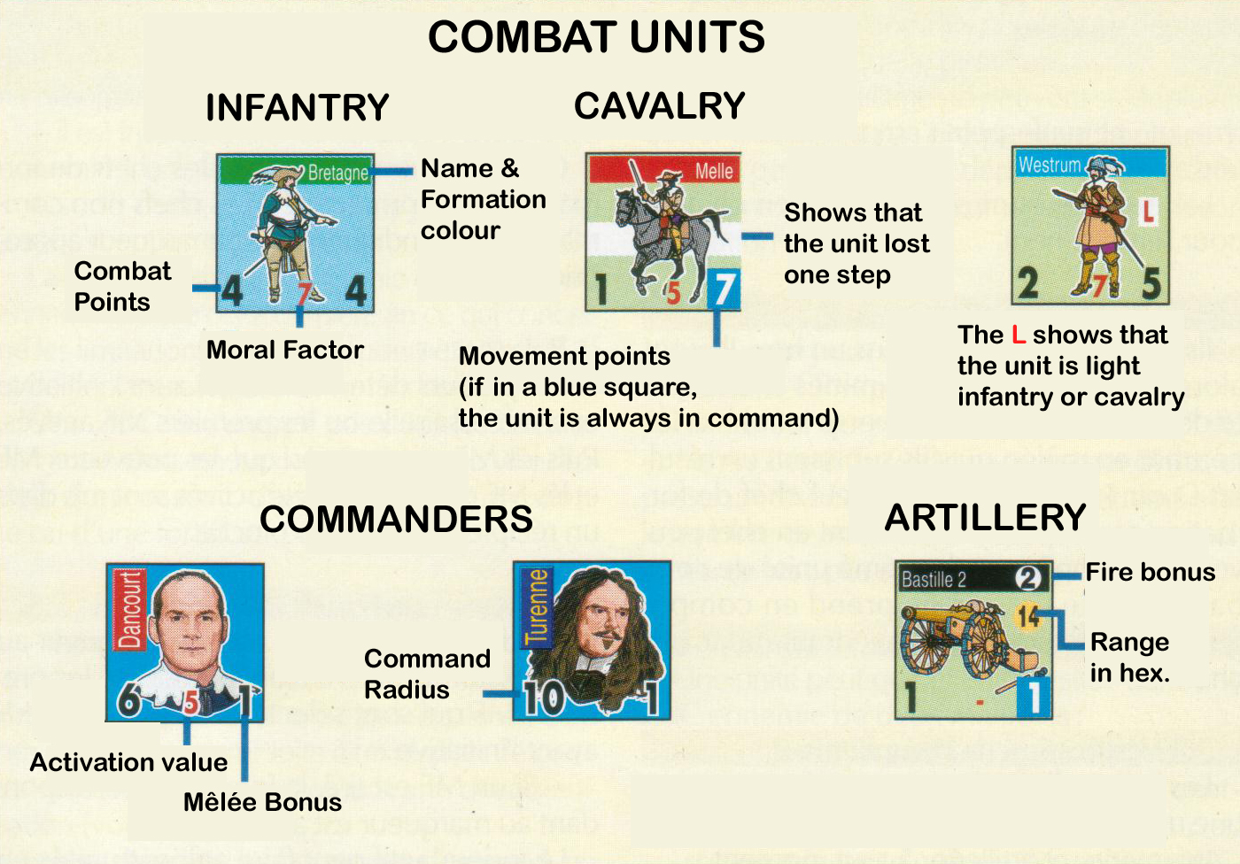

1 - Units
1.1 Combat Units
1.11 Types and characteristics
There are 5 types of combat units:
Light Infantry: Figure on foot and with a capital L. Often represents a detachment of musketeers.
Heavy Infantry: Figure on foot. Around 1650 a mix of pikemen and musketeers. Around 1700 composed solely of musketeers equipped with bayonets.
Light Cavalry: Illustration of a horseman and with a capital L. Around 1650 composed of dragoons, mounted arquebusiers, Cossacks and Turkish Akincis. Around 1700 composed of hussars.
Heavy Cavalry: Illustration of a horseman. Designates, for example, cuirassiers and winged Polish hussars.
Artillery: Illustration of a cannon. From 3 to 12 lb.

1.12 Characteristics
Each infantry, cavalry and artillery counter possesses combat points [CP], a morale factor [MF] and movement points [MP]. The unit is always commanded if its MPs are in a blue square.
  - Fire and mêlée bonuses
Certain units (artillery for example) may have a fire bonus. In the same fashion, incomplete units or with a specific training (e.g. heavy infantry without pikemen or Polish hussars) have a mêlée penalty or bonus.
1.14 Formations
Infantry, cavalry and artillery units are grouped into formations identified by a coloured band at the top of the counter. This formation corresponds to a cavalry formation, to the main body of the army, or to a body of mixed troops. This system of organisation is used for activation, units of the same formation always acting together (see 6).
1.15 Losses
Combat units possess one or two combat steps.
A unit that only possesses one step is eliminated at the first step loss.
When a unit with two steps loses one it is turned over. If the unit has already been flipped, it is eliminated.
1.2 Commanders
The players each possess one, or several, commanders in chief. Each Commander in Chief has a Command Radius [CR] and a Mêlée Bonus [MB]. The Formation Commanders represent the commanders of the various formations in each army. Formation Commanders have an Activation Value [AV], a Command Radius [CR] and a Mêlée Bonus [MB]. A Formation Commander is always in command if his Command Radius is in a blue square (no examples in ‘La Fronde’).

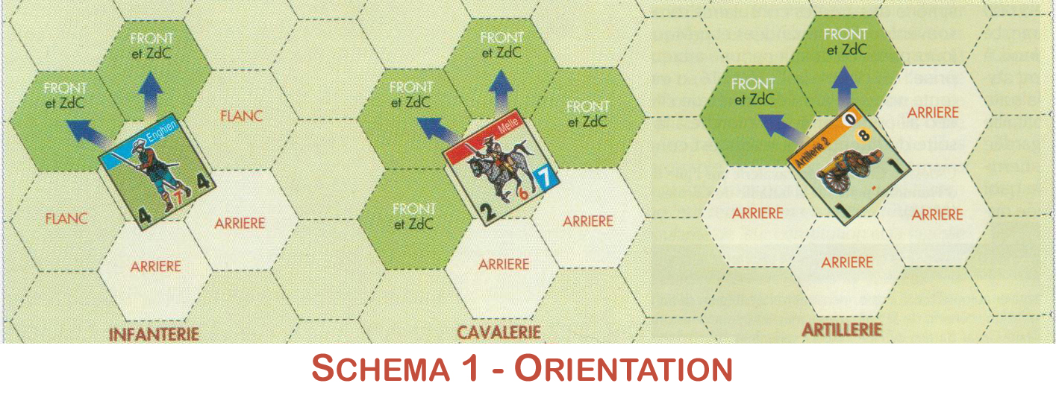

2 – Facing (See Diagram 1 above [Schéma 1 – Orientation])
All units are subject to the facing rules, which influence movement, ZOCs and combat. Each unit is positioned so that its front faces a vertex of the hex.
2.1 – Infantry
Infantry units have two frontal hexes, two flank hexes and two rear hexes. A unit in hedgehog formation has six frontal hexes.
2.2 – Cavalry
Cavalry units have four frontal hexes and 2 rear hexes. Only two frontal hexes are used for movement.
2.3 – Artillery
Artillery units have two frontal hexes and four rear hexes.
2.4 – Commanders and Routed Units
These units have no facing. They may use any adjacent hex to move. (A routed unit must move towards its own exit map edge).
2.5 – Terrain Effects
The terrain in a particular hex may affect the facing of the occupying unit. See Terrain Effects Chart

3 - Stacking
3.1 Stacking Limits
Stacking is limited to one unit per hex.
Exception: One infantry unit or one cavalry unit may be stacked with an artillery unit.
Markers do not count against stacking.
3.2 Commanders
They may be alone in a hex. In this case they are automatically eliminated if an enemy combat unit moves through their hex, carries out a mêlée combat against them, or if they are fired upon and the result is D or 1. One Formation Commander and one Commander in Chief may be stacked on the same combat unit. In this case, only the characteristics of the Commander in Chief are used.
3.3 Application of Stacking Rules
Stacking limits apply to:
- Infantry and artillery units: at all times.
- Cavalry and commanders: only during retreats and at the end of movement.
Historical note: While moving, cavalry had a slightly more flexible formation than infantry. It could thus reform much more quickly.
3.4 Penalties for overstacking
If units are overstacked the owning player must eliminate as many as required to meet the stacking limits. If there are two commanders overstacked, one of them is moved in order to meet stacking requirements.
3.5 Effects of stacking with artillery
3.5.1 When a unit stops its movement in a hex occupied by an artillery unit, the player must decide which unit is on top of the stack. Only the upper unit my fire, be the target of enemy fire and participate in a mêlée. The other unit may nevertheless carry out a reaction movement.
3.5.2 The stacking order may be changed during phase 2a of an infantry or cavalry unit’s movement, or instead of the firing phase (including reaction fire) of an artillery unit. In the latter case, the artillery unit changes its position in the stack, and is considered as having fired.
3.5.3 The two stacking units may have different morale values and may face in different directions.
3.6 Inspection
Both sides may inspect any stack of friendly or enemy units.

4 – Game sequence
A GRAND SIECLE game is played in a set number of turns, each turn consisting of several phases.
A. Command
Each player checks that Formation Commanders are in command. Commanders who are out of command are indicated as such with the appropriate marker. (see 7.2).
B. Initiative
Players determine who will have the initiative, and if necessary the first activated MF chit(s). Then the remaining MF chits as well as new ME chits and any ME chits which have not yet been activated are put into an opaque container
C. Activation
One of the players draws a chit at random from the container, apart from the first MF chit(s) already selected by the player with the initiative:
- If an MF is drawn, the corresponding unit is activated.
The active player may perform the following actions in strict sequence:
0. Check which units in the formation are in command
1. Artillery fire (see 10)
2a. Movement (except artillery having fired in 1.) - (see 9)
2b. Reaction movement or reaction fire of inactive units (during 2a)
3. Cavalry or infantry fire (see 10)
4. Mêlée (see 11)
5. Rally routed units (see 13.5) and reorganise units outside an enemy ZOC (see 13.2)
- If an ME chit is drawn, the player indicated in the scenario rules tries to carry out the event, and applies the effects if successful (see 6.2)
The activation phase is repeated until there are no more MF or ME chits to be drawn.
D. End of turn
The ‘out of command’ [Non commandé] markers are withdrawn from Formation Commanders.
The players check the automatic victory conditions.
The turn is then completed and the turn marker is advanced one space.
At the end of the final turn the players check the victory conditions for that scenario.

5 - Initiative
The formations of both sides are activated by drawing chits at random..
This order of activation can however be altered by the initiative of one of the players. Each player rolls 1D10, adds to that the bonus of his Commander in Chief, and deducts 1 per demoralised formation. The player with the higher result gains the initiative and chooses from amongst his MF the first MF he wishes to activate. If a player wins the initiative with a score which is more than double that of his opponents, he must choose the first MF to activate from his own MFs, and then he chooses the second MF to be activated either from one of his own MFs or from his opponent’s MFs. In both cases, normal activation is resumed subsequently. In the event of an equal score neither player has the initiative, and all MFs are drawn randomly.

6 - Activation
6.1 – Activation Markers [Chits]
The chits/markers to be drawn are of two kinds: formation and events.
6.1.1 Formation Markers/Chits: MF
MFs allow players to know which formation to activate. Each MF represents a formation of the same colour code. Each formation has a MF. The MFs in play are placed in an opaque container (Phase B), to be drawn at random during phase C. At the end of a turn, if there are no remaining units in a given formation, the MF and the commander of that formation are removed from play.
6.1.2 Event Markers/Chits: ME
Events are distinguished by a specific name on the chit and an activation value. Certain MEs arriving during the game are either placed straight into the container to be drawn at random, or are given directly to the relevant player (see the specific rules for the MEs in the scenario). This player can choose to place the counter into the container with other reinforcement chits, or he can put place it in later, after the initiative phase (Phase B).
Every ME has to be activated for the owning player to be able to carry out the event (see 6.2).
If a specific rule relating to a ME contradicts the standard rules of the game, the specific rule of that ME is given priority.
6.2 – Use of the Markers/Chits
At the start of the activation phase (Phase C), one of the players draws a chit at random from the container.
If he draws a MF, the units of the formation activated by that MF are then activated and may carry out actions in the order laid out in the sequence of play above. When the owning player has carried out all the actions he wishes with the units of that formation, the MF is put aside and a player draws another chit, repeating the process above. The Commander in Chief is activated each time a marker from his army is drawn. At the end of the formation’s activation the Formation Commander’s counter is flipped to indicate that the formation has been activated.
If an ME is drawn, the player designated by the special rules checks to see if the event is activated by rolling a 1D10. If the result is lower than the ME’s activation value, its effects are applied. If the event is not activated, the chit is put aside to be redrawn next turn, and the player draws a new chit. Unless otherwise stated, the Commander in Chief cannot move when an ME is drawn.
When there are no more chits left in the container, the activation phase is ended.

7 – Command (See Diagram 2 below [Schéma 2 – Commandement])
7.1 – Command of a formation
Each Commander in Chief has a Command Radius [CR] (expressed as a number of hexes, which is unaffected by terrain) which represents his ability to control his Formation Commanders.
To be in command a Formation Commander must be in the CR of his Commander in Chief during phase A. The CR is traced from the Commander in Chief to the Formation Commander following a line of hexes (unaffected by terrain) which may not pass through an enemy unit, nor through a frontal or flank hex of an enemy unit which is not occupied by a friendly unit.
7.2 – Formation out of command
A Formation Commander out of command in phase A has an ‘out of command’ [Non commandé] marker placed on it. If the MF for an out of command Formation Commander is drawn, the commander must carry out an activation check. The Formation Commander is activated normally if the player rolls a 1D10 lower than or equal to the commander’s activation value.
If the test is failed, the counter is flipped, as if the Formation Commander had been activated, and the formation’s units act as if they were out of command, without regard to his CR.
7.3 – Command of Units
When activated a Formation Commander may make all the units of his command that are in command at the moment of activation perform any actions open to them. To be in command, a unit must be within the CR of the Formation Commander, following the same principles as in rule 7.1.
A unit which is outside the CR of its commander is still in command if:
Infantry or artillery: the unit forms part of a line of battle that is in command (see 7.5).
Cavalry: the unit is two hexes from another unit in command or from a line of battle. No account is taken of the cavalry unit’s facing.
The command check of a formation’s units is done at the moment of the formation’s activation. This means that a unit that is out of command remains so for the whole phase, even if the Formation Commander moves to within range of his CR.
A Formation Commander does not need to be stacked with units of his formation in order to be able to command them.
7.4 – Out of command units
A unit that is out of command at the moment of its formation’s activation may not attack. It may nevertheless change facing and move, but with only half of its MPs. Any movement which the unit does make must on no account not move it further away from its commander. An out of command unit which wishes to move out of an enemy ZOC must use all its movement points to do so.
7.5 – Lines of battle
Adjacent infantry units of the same formation, in the same facing, sharing flank hexes and which are not routed, form a line of battle.

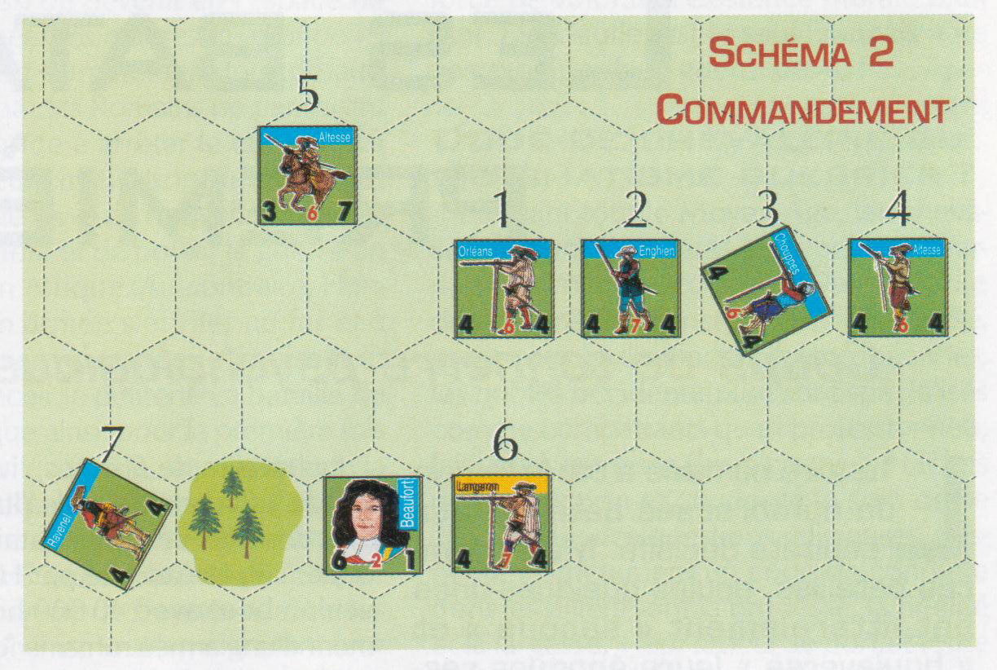
Beaufort has a CR of 2.
Unit 1 is in command because it is in range of its Formation Commander‘s CR.
Unit 2 is in command because, even if it is out of range of Beaufort‘s CR, it is adjacent to an in command unit with the same facing. They are part of the same line of battle.
Unit 3 has a different facing than the other adjacent units and therefore it is out of command.
Unit 4 is out of command because it is out of range of Beaufort‘s CR and unit 3 broke the line of battle.
Unit 5 is in command because it is a cavalry unit within 2 hexes of a commanded line of battle.
Unit 6 is out of command because Beaufort is not its Formation Commander.
Unit 7 is in command because the woods have no effects on Command.

8 – Zones of Control
Each unit has a Zone of Control (ZOC) in each of its frontal hexes, which affects opposing units in these hexes. Commanders, artillery units and routed units do not have any ZOCs. See the terrain effects chart for modifications to ZOCs for units occupying town, redoubt or fortification hexes.
8.1 – Effects of ZOCs
A ZOC has the following effects:
- a unit that enters an enemy ZOC stops its movement;
- a unit that retreats into an enemy ZOC after combat may become disorganised and be routed (see 12.2);
- a unit may not move directly from one enemy ZOC to another enemy ZOC;
- leaving an enemy ZOC costs +1 MP, (unless retreating out of the ZOC, see 9.3).
The presence of a friendly unit in an enemy ZOC negates the effects of the ZOC for command (see 7.1) and the movement of commanders (see 9.4).
A ZOC is not projected into the following terrain; a forest or town hex, or across a stream, river, redoubt or fortification hexside.
8.2 – Properties of flank and rear hexes
Flank hexes: the flank hexes of enemy units have no effect on the movement of friendly units. A unit which retreats into an enemy flank hex after combat may possibly become disorganised (see 12.2).
Rear hexes: the rear hexes of enemy units have no effect on the movement of friendly units. There is no penalty for retreating into the rear hex of an enemy unit after combat.
9 – Movement (See Diagram 3 below [Schéma 3 – Mouvement])
9.1 – General
An activated unit or Formation Commander may move some or all of its MPs. Entering a hex costs the moving unit a certain number of MPs. Terrain costs are shown on the Terrain Effects Chart. MPs are not cumulative from one turn to the other; neither may they be transferred between units. The movement of a unit or stack of units must be completed before continuing to another unit of that formation.
A unit that carries out all its movement by road is awarded 1 extra MP.
Movement for combat units can only be carried out through frontal hexes, without changing facing. Commanders may move in any direction.
Artillery units may only move if they have not fired during phase 1. Even if limbered, they may not move into terrain which would result in automatic disorganisation.
9.2 – Changing facing
A unit may change facing by expending 1 MP per vertex.
A unit that changes facing in an enemy ZOC must pay 2 MPs per vertex and must undergo a morale test (one test only, irrespective of the number of vertexes). Whatever the result of the test, the unit still changes facing.
9.3 – Leaving an enemy ZOC
A unit may leave a hex in an enemy ZOC in one of two ways:
- either by advancing through one of its frontal hexes, provided that hex has neither an enemy unit in it, nor is it in an enemy ZOC. Cost: + 1 PM.
- or by retreating one hex (following the retreat rules, see 12.2) into one of its rear hexes (but not a flank hex), while maintaining its facing. Cost: half its MPs (plus the terrain cost of the hex being moved into). The unit may change facing after it has retreated.
9.4 – Moving commanders
Commanders in Chief may move 7 MPs every time a friendly MF is drawn. But they may not enter an enemy frontal or flank hex that is not occupied by a friendly unit.
A Formation Commander may move 7 MPs, like a cavalry unit, but only when his own formation has been activated.
9.5 – Reaction Movement
Once per activation of an enemy formation, a cavalry unit or a commander on his own may react to an enemy movement if the enemy unit arrives within 2 hexes of it, and if the initial MPs of the enemy unit (after any modification due to disorganisation) are less than the reacting unit. The unit may then move normally, but may not become adjacent to an enemy unit.
9.6 – Hedgehog
If a cavalry unit moves to within 2 hexes of a frontal or flank hex of a heavy infantry unit which is not disorganised, the infantry unit may attempt to move into hedgehog formation by passing a morale test.
If the heavy infantry unit passes the test, the owning player places a hedgehog marker on it. It may no longer move or carry out a mêlée attack, but it may still fire. Consult the Fire and Mêlée tables for modifiers for a unit in hedgehog formation. To return to normal formation, the unit must use all its MPs during its movement segment.
If the unit fails its morale test, it becomes disorganised.
Historical Note: Pikemen also had a defensive role in respect to enemy cavalry. Faced by a charge, the musketeers would reform in the centre of the square and the pikemen would deploy themselves on the outside faces, in the hope that their long pikes would discourage the horsemen.
9.7 – Charge
A heavy cavalry unit charges if:
- It has covered at least 2 hexes of clear terrain without changing facing;
- The enemy unit is in clear terrain.
A ‘Charge’ marker is placed on the unit, which may not fire in segment 3 of phase C. A unit which carries out a charge may only attack one enemy unit, and must resolve the combat on its own, unless another heavy cavalry unit attacks the same enemy unit..
Historical Note: The cavalry of the era no longer used shock as the principal method of breaking enemy formations, preferring fire instead (with the exception of the Swedes). The charge at the gallop would be reintroduced by Marlborough for the British Army, and only by the Maison du Roi in the French Army.
9.8 – Limbered guns
An artillery unit may limber up or unlimber instead of firing in phase C1. Once limbered place an ‘Attelé’ [limbered] marker on the unit. Limbered guns have 3 MPs. Limbered artillery may not move into terrain that would cause it to be disorganised. Once unlimbered during phase C1, the unit may also fire before moving onto phase C2. Limbered guns are treated as normal artillery for all other aspects.
9.9 – Reinforcements
When reinforcements arrive on the map, each unit expends the MP cost of the entry hex, + 1 MP for every unit that has already entered the map through this hex during the present activation. Reinforcements are automatically in command on the turn of their arrival. They may enter the game when they are activated by their formation. If the reinforcements’ entry hex is occupied by an enemy unit, the reinforcements are delayed by one turn

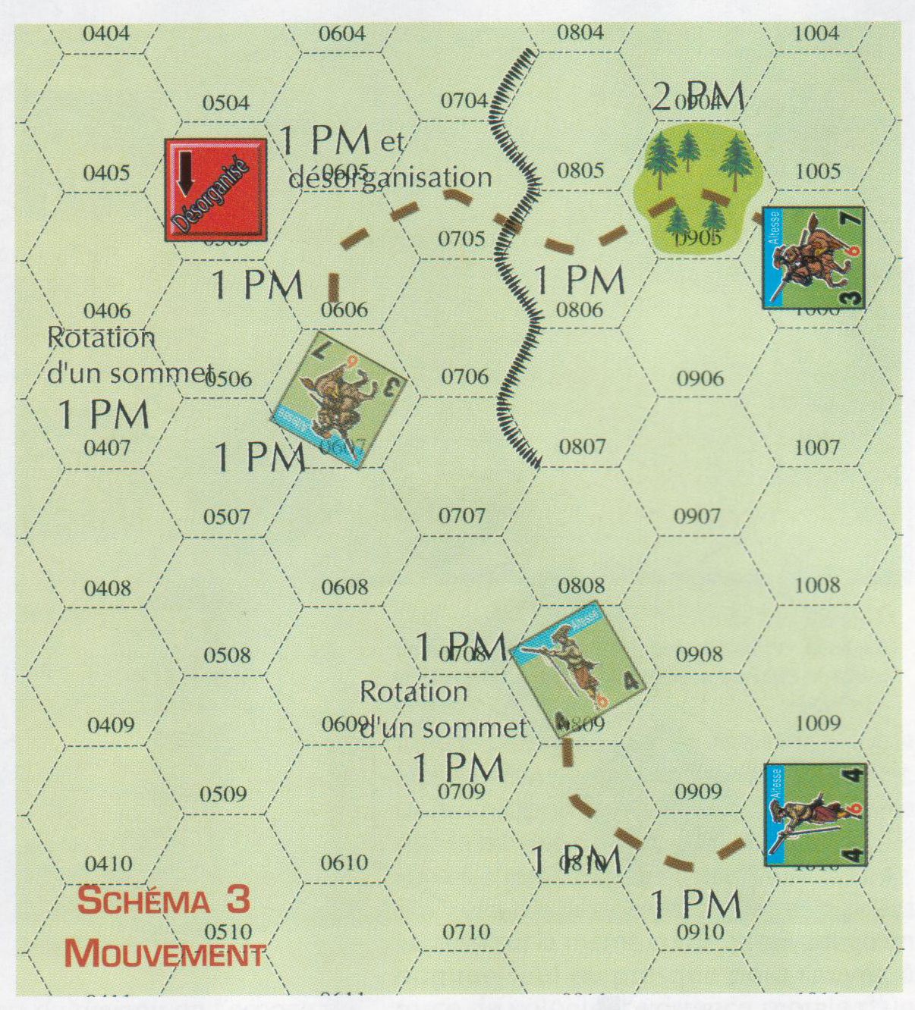

10. Fire (See Diagram 4 below [Schéma 4 – Tir])
10.1 General
During the firing phase units from the activated formation may fire in the direction of their frontal hexes. (see diagram). Firing is voluntary. No unit is obliged to fire. No activated unit may fire more than once per phase. Each unit fires separately.
ARTILLERY: If an artillery unit chooses to fire, it must designate a target which is within range and in its Line of Sight (10.5).
An artillery unit may not fire beyond its maximum range. The range is the number of hexes from the firing unit to its target, counting the hex of the target unit, but not that of the firing unit.
Designer’s note : Although extreme ranges were possible for field artillery (3, 4 et 6 lbs), it was usual during the period to fire at ranges of 600-800 metres, and often much closer. All artillery of the period was smooth bore and, like the muskets of the day, was very inaccurate when firing at any target that was not at close range.
INFANTRY: If an infantry unit chooses to fire, it must choose an adjacent hex as its target.
10.2 Procedure
STAGE 1: The firing player rolls 1D10 and applies the modifiers.
STAGE 2: He checks the result in the fire table, referring to the column applicable to the firing unit.
STAGE 3: He applies the result to the unit in the target hex (the upper unit if a stack).
10.3 Salvo fire
A unit of heavy infantry, which is not disorganised, may fire a salvo only in phase 3. It may not have moved, nor changed facing in phase 2a.
10.4 Reaction fire
Reaction fire is normal fire that is carried out by an inactive unit, and which is resolved during the movement of an activated unit. If it is still possible after the reaction fire, the activated unit may continue its movement.
A cavalry or an infantry unit may carry out one reaction fire per enemy activation phase if an enemy unit moves into one of its frontal hexes. An artillery unit may carry out one reaction fire per turn if an enemy unit moves into its Line of Sight.
10.5 Line of Sight
Artillery must have a clear Line of Sight as far as its target hex in order to fire. The LOS is traced from the centre of the firing unit’s hex to the centre of the target unit’s hex. Artillery may always fire at a target in an adjacent hex.

Determining the LOS depends on the position of the firing unit and the target, which are either both “elevated”, or not. A unit is elevated if the LOS traced from the other unit traverses a slope.
A. Neither unit or only one unit is elevated: The LOS is blocked if it passes through a hex containing blocking terrain. In addition the LOS is blocked if it crosses a slope that does not belong to the hex of either the firing or the target unit.
B. Both units are elevated: The LOS between these units is always clear. Ignore any blocking terrain.

Elements that block the LOS are:
- any unit between artillery and its target;
- any obstacle hex (town, forest, fortification or redoubt), hex sides excluded, between the artillery unit and its target.
A LOS may always be traced into a hex containing blocking terrain, but never through it.
If a LOS passes along a hex side, it is only blocked if the hexes on both sides contain blocking terrain

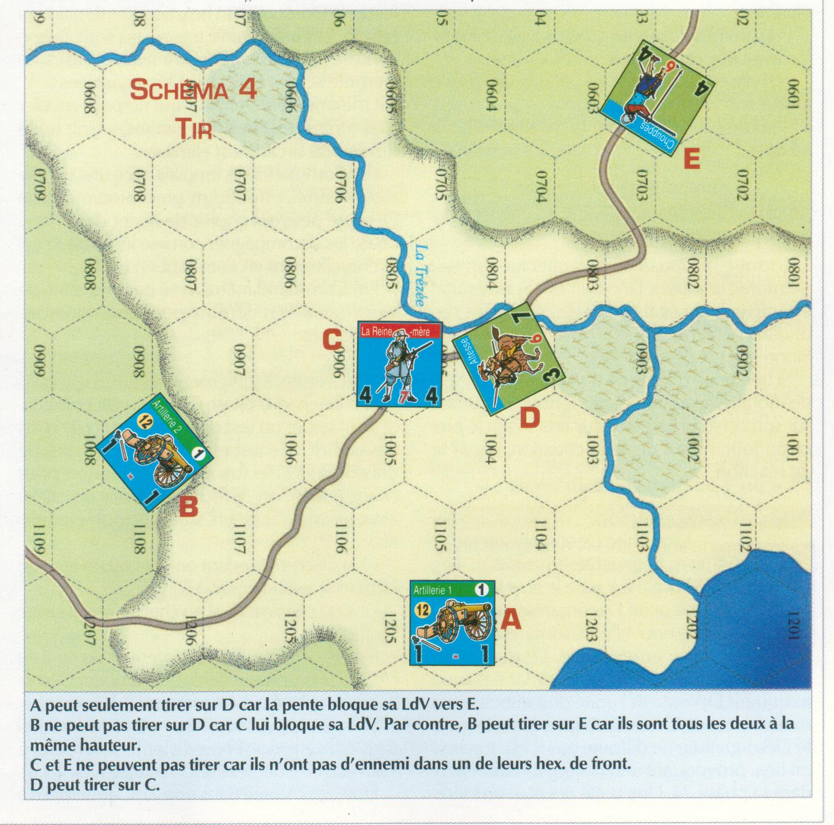
A can only fire on D because the slope blocks its LOS to E.
B cannot fire on D because C blocks its LOS. On the contrary, B can fire on E because they are both at the same height.
C and E cannot fire because they have no enemy in either of their frontal hexes.
D can fire on C.

11. MELEE
11.1 - General
A unit may attack only when its formation has been activated.
Exception: Artillery units may not carry out mêlée combat.
A unit may engage one or several enemy units if these are all located in its ZOC and are all adjacent to one another. In this case it engages them all simultaneously, and their Combat Points are combined. Similarly, several friendly units adjacent to each other and which are not in another enemy unit’s ZOC may combine their CPs to attack the same enemy unit. However, several friendly units may not combine to engage several enemy units simultaneously; in this case the attacks must be resolved individually.
A unit may be attacked several times per turn but only once per enemy formation activation.
11.2 – Procedure
Each mêlée is resolved separately.
STAGE 1: Determine the ratio between the attacker’s CPs and the defender’s CPs. This strength ratio is always rounded in favour of the defender.
STAGE 2: The different modifiers (see 11.3) are applied and the attacker rolls 1d10. The result is obtained by referring to the Combat Results Table.
STAGE 3: The result is applied immediately before moving to the next combat.
11.3 - Modifiers
The combat modifiers are as follows:
Terrain: when several units are attacked simultaneously, apply the most advantageous defensive terrain effect for combat resolution.
Morale: calculate the difference between the attacker’s and the defender’s Morale Factors. If units from the same side but with different MFs are engaged in the same combat (in attack or in defence), apply the best MF of the units involved.
Flank and rear attacks: an infantry unit attacked in the flank gives a DRM of +1 to the attacker. A unit attacked in the rear gives a DRM of +2 to the attacker. For attacks involving several units, always use the facing that is most unfavourable to the defender.
Routed units: If all the defending units are routed the attacker benefits from a DRM of +3. This DRM is not cumulative with a DRM for flank or rear attacks.
Cavalry attacking or defending a town, redoubt or fortification hex: A cavalry unit attacking or defending against an enemy unit in a built up zone suffers a -1 DRM.
All modifiers are cumulative.
12 – Combat Results
12.1 - Results
Possible results for Fire (see 10) and Mêlée (see 11) are as follows:
TM: Morale Test. All the units affected undergo a Morale Test.
D: Disorganisation. All affected units are disorganised.
R1 or R2: Retreat of 1 or 2 hexes for all affected units (see 12.2).
*: If the unit concerned is a cavalry unit that has already been disorganised in a preceding combat, it is eliminated.
1 or 2: The number of steps eliminated in the affected units. The owning player is free to determine which units take the losses.
E: Elimination of the affected units.
The results are applied in the following order: losses (or possible elimination of an already disorganised cavalry unit), disorganisation, morale test then retreat.
12.2 - Retreat
Retreat after combat must be done in the following order: towards of one of the retreating unit’s rear hexes (even if it ends inside a redoubt or fortification hex), failing that into terrain that the unit may enter. This retreat hex must if possible be out of any enemy ZOC or enemy flank hex; it must also be free of any friendly unit that would be in violation of stacking limits.

A unit that cannot retreat because of the presence of enemy unit(s) in adjacent hexes, or because of impassable terrain, is eliminated.
A unit forced to retreat into a frontal hex of an enemy unit undergoes a Morale Test with a DRM of -3.
A unit forced to retreat into a flank hex of an enemy unit undergoes a Morale Test with a DRM of -1
A unit forced to retreat into a rear hex of an enemy unit does not undergo a Morale Test.
A unit that retreats into a hex containing a friendly unit with which it may not be stacked, displaces the latter, so that the retreating unit may move into the vacated hex. The displaced unit is automatically disorganised. This new retreat may engender other retreats in sequence. The normal rules of retreat apply in full, over and above the automatic disorganisation. The owning player is free to eliminate a unit, thereby also eliminating its retreat, rather than suffer supplementary retreats.
A commander must retreat with the unit he is accompanying.
12.3 – Advance after Mêlée
In the case of retreat or elimination, one of the victorious units, in attack or defence, may enter the vacated hex. The advance is limited to this one hex, with the same facing, even if the retreat is of two hexes. The choice of whether to advance or not is free, but must be carried out immediately and before any other action. Artillery may not advance after combat.
12.4 – Elimination of Commanders in Chief
A Commander in Chief is eliminated when the units with which he is stacked are eliminated entirely, whether by combat, fire or retreat. If he is alone in a hex he is automatically eliminated if an enemy combat passes through his hex, if he takes part in a mêlée, or if he suffers a result of D or 1 as a result of fire. He is then immediately replaced by one of the Formation Commanders (owning player’s choice) who becomes Commander in Chief for the rest of the game, and whom the player places on any friendly unit. A Maréchal de camp of the same formation as the former Formation Commander is then placed on any unit of that formation.
The elimination of the Commander in Chief affects Formation Morale (see 14.1).
12.5 – Elimination of Formation Commanders
A Formation Commander is eliminated when the units with which he is stacked are eliminated entirely, whether by combat, fire or retreat. The Formation Commander is then immediately replaced by his Maréchal de camp (identified by the appropriately coloured bar), which the player places on a unit from the formation. A Maréchal de camp that is killed is replaced in the same fashion. If the Formation Commander is alone in a hex, he is automatically eliminated if an enemy combat unit passes through his hex, engages him in mêlée combat, or if he suffers a result of D or 1 as a result of fire.
His elimination affects Formation Morale (see 14.1).
12.6 - Destruction of Artillery
An artillery unit is automatically eliminated:
- if the infantry or cavalry unit with which it is stacked is eliminated or forced to retreat;
- if it is alone in a hex and is engaged in mêlée (after its reaction fire) ;
- if it suffers a result of D or 1 following enemy fire.

13 – Unit Morale
13.1 – Morale Test
When a unit has to carry out a Morale Test, the owning player rolls a die. If the result is lower than or equal to the Morale Factor [FM] of the unit, it remains in its present state. Otherwise it becomes disorganised.
If an artillery unit has to carry out a Morale Test, it is automatically flipped onto its reverse side and may not fire until the next turn, neither during its activation nor as reaction fire.
13.2 - Disorganisation
A disorganised unit has a Disorganised [Désorganisé] marker placed on it. A unit that is disorganised suffers penalties in Fire and Mêlée. A disorganised unit that suffers a second disorganised result is routed. The Disorganised marker is removed and replaced by a Routed marker, and the unit routs. However a disorganised unit is not routed if during phase 2a it passes through a hex requiring disorganisation. A unit that becomes disorganised while in Hedgehog formation loses its Hedgehog marker.
Attention: a cavalry unit which is already disorganised may become immediately eliminated, no matter how strong it is, if it suffers a * result as a result of combat.
The Disorganised marker is removed in Phase C5, if the disorganised unit is not in any enemy ZOC at that moment.
13.3 – Rout
A routed unit may only attempt to rally itself when it is activated. It no longer possesses any ZOC, and it has no facing. Any movement, other than rout, is forbidden.
A routed unit that suffers a fresh result of Disorganised or Routed is immediately eliminated.
13.4 – Rout Movement
As soon as a unit routs, at any point in the turn, it must immediately rout 3 hexes, irrespective of the terrain, unless that terrain is impassable for that particular unit.
This movement must be towards the nearest friendly map edge, as specified by the scenario instructions.
Any further rout (caused for example by a failed rally test) causes a new rout of 3 hexes towards the friendly map edge. This movement must also be carried out completely, otherwise the unit is eliminated. The path chosen may be more or less direct providing the unit is able to carry out its full rout requirement.
A routed unit may pass through friendly units without regard to stacking limits except for the final hex, in which case an extra hex of rout movement is required. The traversed units become disorganised in their own turn (indeed even routed if they were already disorganised).
A routed unit that cannot retreat at least 3 hexes is eliminated. A unit that leaves the map is eliminated.
Commanders stacked with one or more routed units may choose to remain in the hex or to accompany them, as in a retreat, possibly stopping en route. A Commander traversed by a routed unit from his formation may choose to accompany them.

13.5 – Rally Test
In each phase C5, a routed unit may attempt a Rally Test if it is not in an enemy ZOC. This test is compulsory. Each unit carries out a Rally Test individually; a 1D10 is rolled with the following modifiers applying (not cumulative):
- 1 if a Commander in Chief is adjacent to the unit.
- 1 if its own Formation Commander is stacked with the unit.
- 2 if a Commander in Chief is stacked with the unit.
If the result is equal to or less than the unit’s morale factor it is rallied, and the Routed marker is replaced by a Disorganised marker.
If the result is higher than the unit’s morale factor, it must immediately rout a further 3 hexes (see 13.4). A unit in an enemy ZOC may not carry out a Rally Test and must continue its rout; i.e. the owning player acts as if the unit had failed a Rally Test, and immediately routs it further 3 hexes.
14 – Formation Morale
Historical Note: In the 17th century whether or not an army won or lost a battle depended more upon the evolution of its morale than upon losses suffered, which were only one factor among others. Formation Morale is a measure of the willingness to fight of the soldiers in that formation. The success or failure of individual units has a cumulative effect on the overall morale status of that formation.
14.1 Morale Status
Each formation starts the game with a certain number of Morale Points. During the battle each changes in a formation’s morale status are indicated on the morale table, using the marker provided for that formation. A formation becomes demoralised when its marker reaches 0 on the General Track. Turn the Morale Marker onto its reverse side to indicate its demoralised status and to count negative morale points. A formation may regain its morale (and thus lose the negative effects of demoralisation).
A formation’s morale is modified at the moment one of the following events apply:
- A unit from the formation is routed: - 1 morale point
- A unit from the formation is eliminated: - 2 morale points
- The Formation Commander is killed: - 2 morale points
- The Commander in Chief is killed: - 2 morale points for every formation
- A routed unit which regains disorganised status: +1 morale point
- The Commander in Chief is stacked with a unit belonging to the formation: +1 morale point. [This point is withdrawn as soon as the Commander in Chief is no longer stacked with a unit of that formation.]
14.2 – Effects of demoralisation
From the moment a formation becomes demoralised, and for as long as it remains in that state, all the units that belong to the formation suffer the following penalties:
- A disorganised unit remains disorganised for as long as the formation is demoralised.
- The Morale Factor of the units in a demoralised formation is decreased by – 1.
- No unit belonging to the formation may voluntarily enter an enemy ZOC.

15 – Victory Conditions
15.1 Automatic Victory
If at any point in the game all the formations still in play of any one side become demoralised, the other player wins a Major Victory.
15.2 Victory at the end of the scenario
If at the conclusion of the scenario neither player has succeeded in gaining a Major Victory, the winner is determined by checking the victory conditions for that scenario.

TERRAIN EFFECT TABLE

Type of terrain | Cost in MPs | Fire | Mêlée | Blocks ZOC | Observations
Clear | 1 | - | -
Difficult (hedges, low walls,…) | 2 | - | -
Wood | 2 | -1 | -1 | Yes
Marsh | 3D | - | -1 | Yes
Town / Village | 2 | -2 | -1 | Yes | Flank hexes of infantry occupying these hexes are considered as frontal hexes.
Road | 1 | Hex terrain applies | Hex terrain applies |  | Negates the extra cost linked to crossing a stream, redoubt, fortification or change of elevation.
River / Pond | IMP | - | IMP | Yes
Stream / Ford | +1 | - | -1
Bridge | 0 | - | -2
+1 level of elevation | +1 | -1 | -1
-1 level of elevation | 0 | - | +1
Slope | +1D | - | -1 | Yes | Impassable for artillery
Redoubt | +2 | -1/ - * | -2 / -1 * |  | Units occupying these hexes have 6 frontal hexes. If the redoubt or fortification doesn’t extend over all hex sides, only those hex sides containing this type of terrain are considered as frontal hexes.
Fortification | IMP | -2 / - * | -3 / -1 *

D: Automatic Disorganisation
IMP: Impassable

Notes:
The modifiers apply to units situated in this type of terrain, and that are the target of fire or mêlée.
* : The first figure concerns an attack from the outside of the hex to the inside, and the second figure applies to the reverse case.

FIRE TABLE

Die roll | Heavy Infantry | Cavalry / Light Infantry | Artillery
0 or -
1
2
3
4 |  |  | TM
5 | TM |  | TM
6 | TM |  | D-R1
7 | D-R1 | TM | D-R1
8 | D-R2 | D | D-R2
9 or + | 1 | D | D-R2

Modifiers common to all (cumulative)
– 1 if the target is cavalry or light infantry.
+ 1 if the target is in hedgehog formation.
+ 1 if the target is artillery.
- ? Terrain
+ 2 Salvo fire.
– 1 if the firing unit is disorganised.
– 2 if the firing unit is in hedgehog formation.
– 1 if a unit of heavy infantry is firing having already moved.

Modifiers specific to artillery (cumulative)
+ fire bonus.
-1 per multiple of two hexes (NB: - the adjacent hex is not counted)
Example: the target is 5 hexes away, the fire modifier is –2.

MÊLÉE TABLE

Modifiers

Strength ratio (Rounded in favour of the defender)
- 4/1: +4
- 3/1: +3
- 2/1: +2
- 1.5/1: +1
- 1/1: 0
- 1/2: -1
- 1/3: -2
- less than 1/3: -3

+ or - the difference in morale between the units having the highest Morale Factor on either side.
+ or - the difference in bonuses between commanders taking part in the combat (only 1 per camp).
-2 if at least one of the attacking heavy infantry units has just fired in phase C3
Bonus/penalty for mêlée

Facing
+1 if the defender (or one of the defenders) is attacked in a flank hex.
+2 if he defender (or one of the defenders) is attacked in a rear hex.
Disorganisation
-1 if the attacking unit, or all attacking units, are disorganised.
+1 if the defending unit, or all defending units, are disorganised.
+3 if all defending units are routed.
Terrain
+ or – the defender’s terrain.
Charge
+1 if charging

Hedgehog
-2 Cavalry attack against a unit in hedgehog formation (ignore charge bonus). Applies even if the charge is combined with an infantry attack.
+1 Infantry on its own against a unit in hedgehog formation.

Type of unit
-1 if all attacking units are light.
+1 if all defending units are light.
-1 if a cavalry unit is attacking or defending in a town/redoubt/fortification hex.

All modifiers are cumulative up to a limit of + or -7.

Precision: The +3 against a defender who is routed is not cumulative either with the facing modifiers or the charge modifier.

Results: 1d10 (0 = zero not 10) + or – the modifiers

R = retreat, D = disorganised, 1 = 1 step loss, 2 = 2 step losses * = Cavalry eliminated if already disorganised, E = eliminated

Modified die roll | Defenders | Attackers
-7 to -5 |  | 2 D-R2*
-4 to -3 |  | 1 D-R*
-2 to -1 |  | D-R
0-1 |  | D
2-3 |  | R
4 | --- | ---
5 | R
6-7 | D
8-9 | D-R
10-11 | 1 D-R*
12-13 | 2 D-R2*
14-16 | E

