NEW LANDSHIPS!

By B. M. Jacobs

The original “Landships” game included a number of counters for vehicles that didn’t have rules for their use. The game indicated that these rules would be forthcoming from Clash of Arms in their house magazine, “Art of War”, but unfortunately, none ever appeared. The rules below close that gap. Information concerning these vehicles was gathered from my personal library as well as Internet research. I believe that they are very close as a significant amount of information was available. The fire arcs for the Vickers Light tank No.2 are a best estimate (taken from a fuzzy photo), as I couldn’t find any description or clear pictures on how the weapons were actually laid out.

4.1 New Tanks
All new vehicles have a Break Down modifier of +0 unless specifically noted otherwise. Unless otherwise noted below, each tank mounted MG has a FS of 2.

4.11 The Sturmpanzerwagen Ober Schlesien (1918): The German 1918-1919 tank program included a tank designed by Oberschlesien-Eisen-Industrie. It was a radical design for a fast-moving, lightly-armored assault tank. The design sacrificed armor for speed (almost 12mph) and featured such advanced features as a 57mm main cannon mounted on top of the tank in a central revolving turret, sloped armor, separate fighting and engine compartments, a rear-mounted engine, and a low track run (the tracks were under the tank and only wrapped around half of it). Two small turrets, each containing a single machine gun were located in front of and behind the main turret. The Oberschlesien was manned by a crew of five. Two prototypes were partially completed when the November armistice brought German tank production to a halt.
- Each of the two machine gun turrets has a 180 degree fire arc. The 57mm gun is in a fully rotating turret.

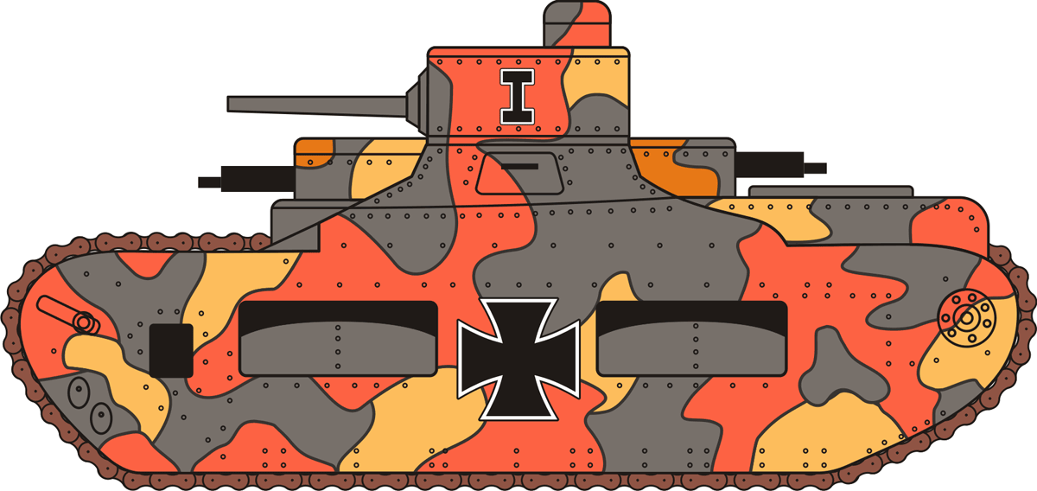

4.12 The A7V/U (1918): Unhappy with the poor cross-country performance of the A7V, German engineers studied the more maneuverable British Mark IV’s captured at Cambrai. The result was a new tank designed along the lines of the British tanks, but using as many of the original A7V components as possible. The 40-ton A7V/U had the same rhomboidal shape and overhead tracks as the MKIV. However, its weapons sponsons were located further back on the hull, and its sprung tracks and high power twin engines gave it twice the speed. A total of twenty were ordered, but only one prototype was completed before the war ended.
- The fire arcs of the main guns and machine guns are identical to the British MKIV tank.

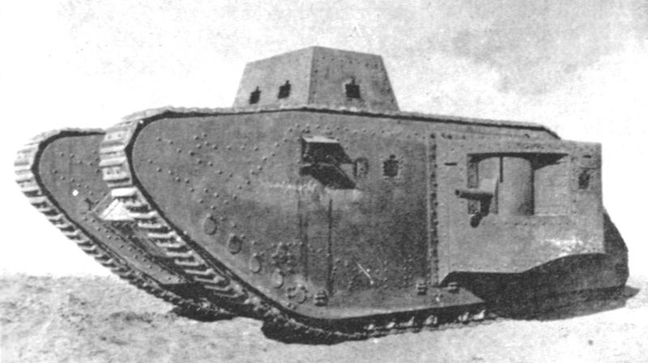

4.13 The Vickers Light Infantry Tank No.1 and No.2 (1921): This tank was the first British tank to have a turret with a 360 degree traverse. Like earlier British tanks, it had high rhomboidal tracks. It also has strongly rounded armor on the turret, and the front of the hull. Two models were built, the No.1 armed with three machine guns in an unusual Y-pattern in the turret, and the No.2 armed with a single 37mm gun and three machine guns in the turret. It was operated by a crew of five. Although well armed and protected, significant mechanical problems with the transmission during demonstrations resulted in the design being discarded in 1922.
- The machine gun and main gun fire arcs are determined by the direction of the first weapon to fire as per the fire diagrams.
- The Vickers Light Infantry Tank design was plagued with problems and mechanically unreliable. The Break Down modifier is +2.

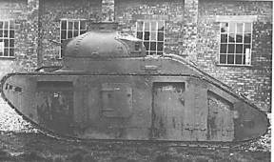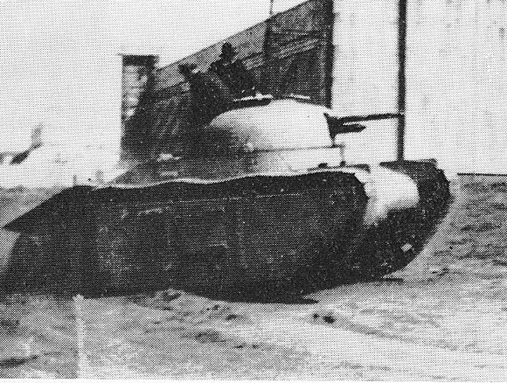
No. 1 No. 2

4.14 The Ford Light Tank (1918): By the summer of 1918, the United States has embarked on a tank production program. In addition to a light and heavy tank, there was a requirement for a machine gun carrier for the infantry. Ford Motor Company produced a successful prototype using many of the parts from the Model T automobile and 15,000 were ordered. However, the Armistice soon followed, the big order was cancelled, and only 15 vehicles were made. This little vehicle was extremely cramped and its single, forward mounted machine gun had a very limited traverse of only 21 degrees.

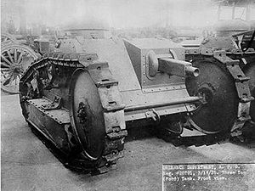

4.15 The Carro Armato Fiat Tipo 2000 Tank (1918): While Italy didn’t begin fielding its first tanks until it acquired French Schneiders in 1917; design work began in 1916 on the first Italian tank, the Fiat Carro Armato. However, lacking experience in tack-laying vehicles, Fiat didn’t complete the two prototypes the Italian government authorized until near the end of 1918. The 40-ton Carro Armato was the first heavy tank to mount a cannon armed turret. The crew consisted of ten men. The Italian Army showed little interest and never used their home produced tanks. Instead, they ordered French tanks which were actually inferior in design.
- The Carro Armato was armed with seven machine guns in the hull; one at each corner, one in each side, and one in the rear. This produces multiple, overlapping fire arcs as shown in the diagram. To simplify things, the Carro Armato can attack anywhere in its line of sight and within range with a maximum of two MGs (total FS of 4), except directly behind the tank, where it can attack with a maximum of three MGs (total FS of 6), and in the areas marked in red on either side of directly ahead of the tank, where it can attack with a maximum of one MG (total FS of 2).

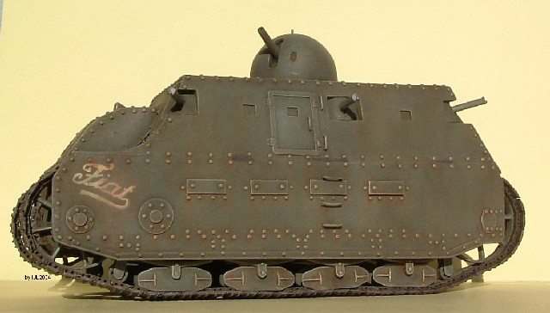

4.4 New Armored Cars (ACs)

4.41 Daimler V4 Armored Car (1915): Impressed with the performance of Allied armored cars at the start of the war, the German Army instructed three leading German motor manufacturers, Daimler, Erhardt, and Bussing, to build prototypes. The V4 had a large, completely enclosed armored body topped with a fixed cylindrical turret and was crewed by eight to nine men. Very few of these vehicles were built (very likely only one) before other forms of war production prevented further Daimler efforts in this area.
- The Daimler V4 was armed with three moveable machine guns and had ten gun ports, including four in the non-revolving turret. Allow any two MGs to engage the same target hex while the third MG must fire at a different one (note: this doesn’t preclude each MG from firing at a different target hex).

4.42 Bussing A5P Armored Car (1915): Along with Daimler and Erhardt, the Bussing firm was instructed to develop the German Army’s first armored car prototypes. The result was a massive vehicle over 30 feet long and symmetrical in appearance. Together with the Daimler and Erhardt vehicles, they were formed into Armored Car detachment No. 1, and went on to serve with distinction in the Transylvanian Alps against the Romanians. Like the V4, very few of these armored cars were built (very likely only one).
- Like the Erhardt 1915 and the Daimler V4, the Busing A5P was armed with three moveable machine guns and had ten gun ports, including four in the non-revolving turret. Allow any two MGs to engage the same target hex while the third MG must fire at a different one (note: this doesn’t preclude each MG from firing at a different target hex).

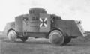

1 x MG (2pts)
1 x MG (2pts)
1 x 57mm Cannon
Ober Schleissen Tank
Weapons: 1 x 57mm Main Gun, 2 x MG
1 x MG (2pts)
1 x MG (2pts)
1 x MG (2pts)
Vickers Light Tank (No. 1)
Weapons: 3 x MG
1 x 65mm Cannon
1 x MG (2pts)
1 x MG (2pts)
1 x MG (2pts)
1 x MG (2pts)
1 x MG (2pts)
1 x MG (2pts)
1 x MG (2pts)
Carro Armato Tank
Weapons: 1 x 65mm Main Gun, 7 x MG

1 x 37mm Cannon
1 x MG (2pts)
1 x MG (2pts)
1 x MG (2pts)
Vickers Light Tank (No. 2)
Weapons: 3 x MG
1 x MG (2pts)
1 x MG (2pts)
1 x MG (2pts)
1 x MG (2pts)
1 x 57mm Cannon
1 x 57mm Cannon
A7V/U Tank
Weapons: 2 x 57mm Main Guns, 4 x MG
1 x MG (2pts)
Ford Light Tank
Weapons: 1 x MG

