Jutland Mini-Games
The following three game situations are presented for those players unable to spend the time required for a full Tournament Game and willing to forego historical realism for game action:

BATTLE OF THE DOGGER BANKS, 24 January, 1915, 0900 hours:

Background
A prelude to Juttand, the Battle of the Dogger Banks resulted from a typical German hit-and-run raid being successfully intercepted by British Battlecruisers based at Rosyth. Having broken the German Navy’s code, the British knew approximately what the German planned to do and had adequate time to raise steam and sail. The battle took the form of a classic sea chase. With the Battlecruisers moving at speeds upward of 28 knots, it became a very near thing for the out-numbered and outgunned Germans. It ended anticlimactically, however, when misinterpreted signals caused the British ships to break off the chase. The Germans lost the Armored Cruiser BLUCHER and had the BC SEYDLITZ badly damaged. On the British side, the LION was badly damaged by eleven large caliber hits. The British made much propaganda out of the affair when in fact they had botched a chance to permanently cripple the German Battle- cruiser squadron.

ORDER OF BATTLE
British | German
BC Indomitable | BC Derfflinger
BC Lion | BC Moltke
BC New Zealand | BC Seydlitz
BC Princess Royal | CA Blucher
BC Tiger | CL-Sg 2a. CL-Sg 2b
CL-Sqd 1, CL-Sqd 2 | DD-½Flot 10, DD-½Flot 17
CL-Sqd 3, DD-FIot 1
DD-Flot 9-10

OB NOTES

1. German CA BLUCHER:
use British BLACK PRINCE counter and hit boxes. BLUCHER has a movement factor of ‘11’.

2. German CL-Sg 2a:
cross off first hit box to represent the proper number of Light Cruisers with the squadron. Does not count for Victory Point purposes.

3. British Light Ships:
for players using the Additional British Forces, replace DD-1 and DD-9-10, and CL-2 with the three units of the Harwich Force.

STARTING POSITIONS

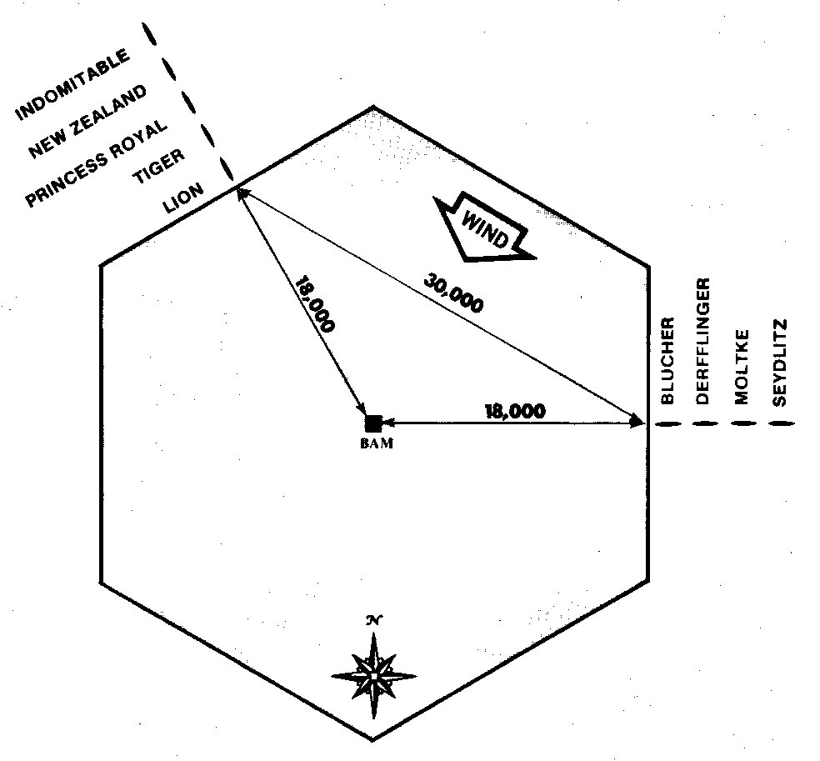
NO SEARCH PROCEDURE. Play begins with both squadrons on the edge of the battle area. Players approximate the ship set-up indicated on the following diagram. Light Ships must be within 4,000 yards of the Capital Ships. Capital Ships must remain in the formations indicated until within 24,000 yards of enemy Capital Ships:

RULES
- Suggested Optional Rules: a) BOTH Weather Variable; b) Smokescreen and c) ALL extraordinary Damage rules.
- Special Rules: a) WEATHER: Visibility at start of game is 36,000 yards and the wind is from the northeast to the southwest b) CAPITAL SHIPS: for both sides, all Capital Ships must be organized into one line-ahead column. These ships must stay in formation unless damage reduces their speed to ‘9’ or less.

TIME FRAME
Daylight hours. Unlimited turns. Game ends when fleets are beyond current maximum sighting range.

VICTORY CONDITIONS
Victory Points are calculated as in the Advanced Game:
BRITISH: British player wins by sinking more Capital Ships than the German player; AND by maintaining more than a 2-1 ratio in Victory Point as compared to the German at the end of the game.
GERMAN: German player wins by sinking as many or more Capital Ships than the British player; OR by maintaining at least a 1-2 ratio of Victory Points as compared to the British at the end of the Game. (NOTE: und these conditions, if no ships are sunk on either side, the German player wins. The burden of decisive action rests with the British player.)

BATTLECRUISER ACTION, 1916-17, 0800 hours:

Background
The following fictional situation typifies what could have occurred if the two opposing Battlecruiser fleets had met on near-equal terms as the Germans planned.
Actually, the German Battlecruiser Fleet would have been operating in conjunction with the main German Fleet somewhere over the horizon, attempting to lure the British into pursuit. From the British point of view, however, they would have been attempting to intercept the enemy Battlecruisers presumably on their way to bombard the English coast (A particularly galling experience for the British, who at the time were loudly propagandizing British control of the North Sea).

ORDER OF BATTLE
British | German
All British Battlecruisers | All German Battlecruisers
CL-Sqd 1, CL-Sqd 2 | CL-Sg 2a. CL-Sg 2b
CL-Sqd 3, CL-Sqd 4  DD-Flot 9-10 | DD-½Flot 3, DD-½Flot 4
DD-Flot 13

STARTING POSITIONS

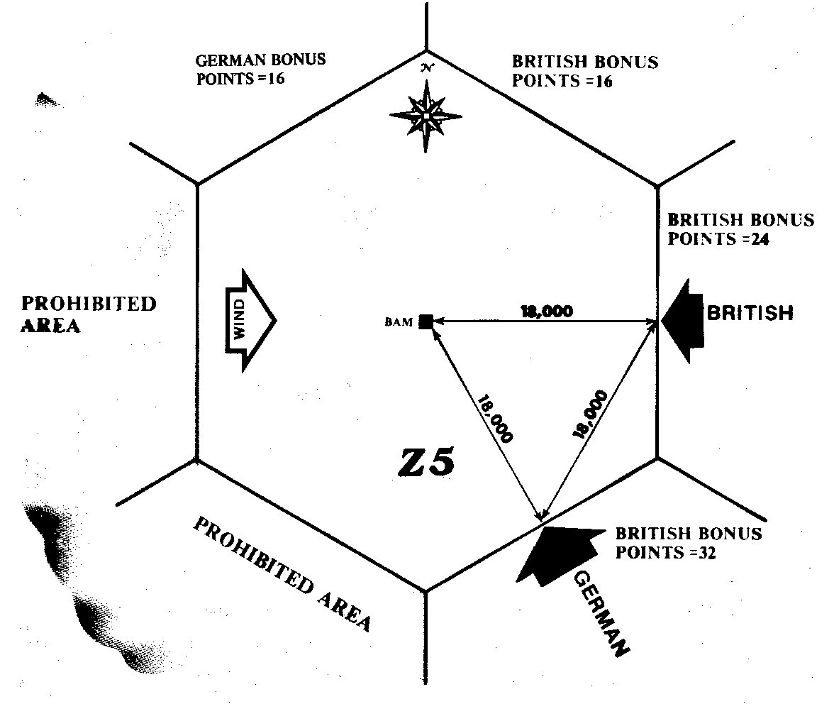

NO SEARCH PROCEDURE. Play begins with both squadrons on the edge of the battle area. Players approximate ship set-up indicated on the following diagram. The battle area represents search sheet hex Z-5. Note that neither side may move more than 20,000 yards west or southwest of the Battle Area Marker as this would carry then into prohibited hexes. It is suggested that players place extra Battle Area Markers in the appropriate locations in the event the battle should move into what would be adjacent search hexes.

RULES
- Suggested Optional Rules: (a) BOTH weather variables; (b) Smokescreen; and (c) ALL Extraordinary Damage Rules.
- Special Rules
- BATTLE AREA EXIT: The Victory Conditions specify Bonus Points being awarded to the German player for the direction and route whereby he exits the battle area. These points are awarded ONLY for the direction the German fleet exits at the end of the game (i.e., when ships are beyond maximum sighting distance). If action moves the opposing fleets into what would be other search hexes, points are determined as follows: if the German fleet is travelling in a north, northwest, west or south west direction when the game ends, the German player is awarded 16 Bonus Points. If the German fleet is travelling in a northeast, east, southeast, or south direction, the British player is awarded 32 points. Players should follow the progress of the battle action on a search sheet to determine prohibited directions of movement and Bonus Points.
- WEATHER: Visibility is 36,000 yards, the wind is from the west to the east.

TIME FRAME
Daylight hours. Unlimited turns. Game ends when fleets are beyond current maximum sighting range.

VICTORY CONDITIONS
Victory Points are calculated as in the Advanced Game with the added provision for Bonus Points based on the German’s exit direction. On the set-up diagram, Bonus Points are indicated for hex Z-5. These bonus points are awarded only for that hex. If the battle is carried into other search hexes, points are awarded as explained in the Special Rules section.
BRITISH: The British Player wins by having as many or more Victory Points at the end of the game than the German player.
GERMAN: The German player wins by having more points than the British player at the end of the game.

FAST RAID AND QUICK REACTION, 1916- 1917:
Background
The following mini-game is a fictionalized representation of what might have happened had the British ‘Quick Reaction’ forces had more of a lead on German raiders than they had historically. Rules have been added to maximize the possibilities for battle action based upon the German need for propaganda victories and the risks they would have taken to get them. The Bonus Point system and the limited German initial move reflect the German thinking in planning raids on the English coast.

ORDER OF BATTLE
British |  | German
At Scapa Flow: | BC Indefatigable | ALL Battlecruisers
BC Indomitable | BC Lion | CL-Sg 2a. CL-Sg 2b
BC Inflexible | BC New Zealand | DD-½Flot 3, DD-½Flot 4
BC Invincible | BC Princess Royal | DD-½Flot 17, DD-½Flot 18
CL-Sqd 4, DD-Flot 4 | BC Queen Mary
DD-Flot 11 | BC Tiger
At Rosyth: | CL-Sqd 2, CL-Sqd 1
BB Barham | CL-Sqd 3, DD-Flot 1
BB Malaya | DD-Flot 9-10, DD-Flot 13
BB Valiant
BB Warspite

STARTING POSITIONS
All forces start in the positions indicated on their respective Task Force cards (German submarines, if used, may not start in shaded hexes. They may move starting the first turn of the game.)

RULES
- Suggested Optional Rules: (a) Both weather variables; (b) Smokescreen; (c) ALL Extra ordinary Damage Rules; (d) British Sweep; (e) Fast Search Speed.
- Special Rules
- SEARCH LIMITATIONS (see diagram, below):The German initial move is limited to hexes within the area to the WEST of the heavy line running SW-SE. The German player must show himself off of an English coast hex unless intercepted during the initial move. If intercepted during the initial move, or after showing himself off of the English coast, he is free to move over all of the search sheet hexes in a normal fashion in subsequent movement. The western part of the search sheet is divided into four areas labelled A through D. A ‘point multiplier’ is provided for each of these areas, ranging from x0 to x4. At the end of the game, the German player’s Victory Points are multiplied by the ‘point multiplier’ depending on either (a) the area he is in when he shows himself off the English coast, or (b) the area he is in when he is intercepted during his initial move. Additionally, the German player is awarded Bonus Points, varying according to the area, if he shows himself off the English coast before he is spotted by the British.
- WEATHER: visibility is 36,000 yards, wind is from the west to the east.

TIME FRAME
Unspecified. Use the time record card as in the normal game. Game ends when all German Battle- cruisers either return to their base or are sunk.

VICTORY CONDITIONS
Victory Points are calculated as in the Advanced Game except that the German’s point totals are modified by the German point multiplier and the Bonus Points awarded for showing himself off the English coast. The Bonus Points are awarded thusly: Area A = 0. Area B = 0, Area C = 10, and Area D = 25.
BRITISH: British player wins if he accumulates more, or as many Victory Points as the German player at the end of the game, or, if any German Capital Ships return to base within twelve hours after being spotted.
GERMAN: German player wins if he accumulates more Victory Points than the British player at the end of the game AND no German Capital Ships return to their base within twelve hours after being spotted.

