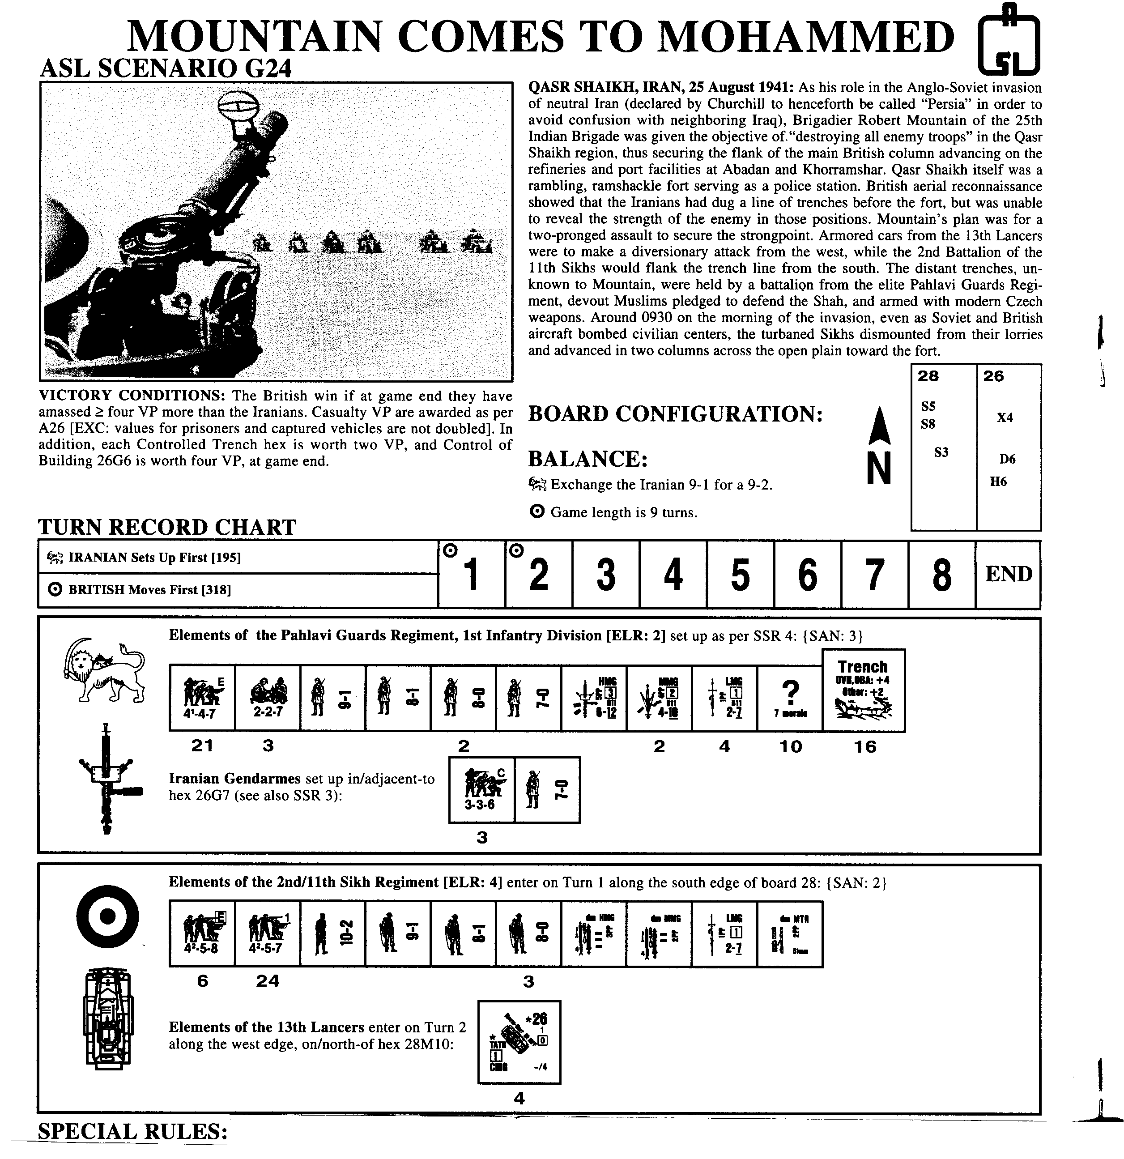

1: EC are Dry with no wind at start. Light Dust (F11.71) is in effect.
2: Place overlays as follows: S5 on 28E8-D8; S8 on 28K8-J7; S3 on 28P5-Q5; H6 on 26W8-W7; D6 on 26M5-M6; and X4 on 26G6. Hammada hexes represent sparse patches of salt-marsh grass; all Hammada hexes are in-season grain that is also Inherent Terrain (B.6).
3. To re-create Fort Qasr Shaikh, place one Crest counter in each of the following board 26 hexes, such that the center-rear arrow points to 26G7: F6, F7, G8, H7 and H6. The Crest-covered hexsides together represent a continuous wall (B9). Overlay X4 represents the gatehouse and barracks, is stone, and may not be Bypassed.
4. Use Axis Minor counters for the Iranians. Prior to setting up ujits, the Iranian player must place one Trench counter in each hex of the following two Hex Grains: 28O1-28H4 and 26O10-26O3. One Iranian 4-4-7 must be placed in each trench. Remaining units of the Pahlavi Guards must be placed in trenches in any manner desired. No Iranian unit in a trench may voluntarily exit from beneath that Trench counter until an unbroken Iranian SMC has a LOS to a Known enemy unit. All Iranian 4-4-7 elite squads in a trench or inside Fort Qasr Shaikh are considered Fanatic.
5. No Quarter (A20.3) is in effect for both sides. British units may conduct Massacres (A20.4).
6. Marmon Herringtons of the 13th Lancers begin the game (off board) bogged in sand. Each turn, beginning with Turn 2, each must make a Bog Removal attempt, and if successful, may then enter the board with any remaining MP. If there are no remaining MP, that AFV may enter the board in its following MPh without having to make an additional Bog Removal attempt.

AFTERMATH: In the Sikh vanguard was Major Colin McVean and Company C, which soon ran into intense automatic-weapons fire from the trench line. Thick stands of salt-marsh grass hindered the line of sight of both sides, and initial losses were light. Meanwhile, the armoured cars of the Lancers had been stopped when they ran into soft sand screening the Iranian left, as well as some effective enemy fire. With one car bogged, and the both the troop leader and his driver seriously wounded, B Squadron made a wide loop to drive to the support of the slowly advancing Indians, kicking up clouds of dust to further obscure the field. The Sikh companies cautiously leap-frogged forward, as the enemy switched their fire from column to the other. Finally, the leading Sikh platoon reached the trenches and leaped into close combat – but the sergeant and his sepoys were overwhelmed and their lifeless bodies were thrown back out. This enraged the rest of the Indian, who stormed the trench line and engaged in no-quarter, hand-to-hand fighting. When the Iranians began to surrender, a full-scale massacre was averted only by the heroic actions of the wounded McVean and other British officers. Some 60 Iranians had been killed and another 300 captured, for 25 Indian casualties. The now-unprotected fort surrendered formally at noon, after a few minutes of close-ranger fire from the circling armoured cars.

