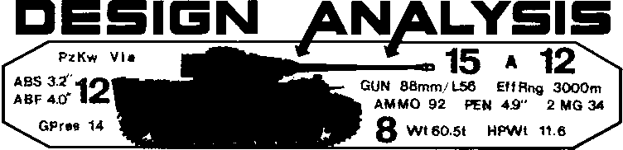

2nd Edition UP FRONT
By Don Greenwood

The following changes have been made to the 2nd Edition version of UP FRONT. Owners of the first edition should note these changes in their rules and components.
RULES:
3.3 Add: "Men may switch positions within a group during their player turn but must do so as the sole action of that group for that turn. Such a position switch is included as part of any successful weapon acquisition (18.2) or assistant crew assignment (11.12)."
8.9 Insert after the first sentence: "Exc: A defending group on a Wall card may subtract only one from the Fire Strength of a mortar or artillery attack."
17.3 Insert after "other," in the last sentence:
"and in which one group may simultaneously flank
two adjacent groups,".
17.62 Add to end: "or both encircling groups find themselves "in front of" the encircled group."
- Add to end of eighth sentence: "unless its
Lateral Group Transfer did not depend on the suc-
cess of the other group vacating the area it is moving
to."
- Insert in fifth sentence between "move" and
"until": "from that range chit."
18.1 Insert after third sentence: "Exc: An in-filitrator who is eliminated leaves his weapon in the infiltrated group."
19.15 EX Delete: "or red 6." Add at end: "Should a red 6 be drawn, the question of which weapon may malfunction is resolved normally."
20.51 Insert after "Fire attack": "by his group."
Add "20.57 An infiltrator may attempt to acquire any unpossessed weapon of the infiltrated group as if it were his own group (18.2), unless that weapon still has a designated assistant crewman.
20.72 Delete "unpinned".
20.74 Add to end of first sentence: "or removing it from play." Add at end: "The man may later voluntarily abandon or destroy his captured weapon only as his group's sole action for the turn."
Add "20.742 If two men eliminate each other in CC their weapons in the infiltrated group for possible acquisition—including acquisition by any infiltrator of the group."
25.41 Change "normally" to "only".
Add "28.32 The TEM of an AFV's current terrain does not affect five vs the Morale and CE defense values of that AFV. The TEM of an AFV's current terrain does affect the first strength of a hit against the Armor and Flank defense values of that AFV (EXC: HullDown; 28.92). The movement status of the defender does not alter the Fire Strength of a hit against AFV targets."
28.4 Delete "also exceeds"; substitute " ^".
28.61 Delete "during . . . resolution."
28.7 EX Delete "and a red 2 RNC would im-mobilze it". Substitute: "or immobilize it (depending on the color of the next RNC drawn)."
30.3 Note that an incorrect counter face is shown as the reverse of the Panzerfaust marker.
32.21 Insert after "firepower": "an CCV". 39.5 Delete: "printed German".
Delete 41.4 entirely. 41.41 now becomes 41.4. Add new 41.41 which reads: "Fire into a different game must be resolved before attacks from that same game are resolved against the same target."
ACTION CARDS:
Change the black 7 under column 9 to a black 1 on card #7.
The Marsh cards should have a - 1 TEM; not +1.
All Movement cards with a black RNC incorrectly refer to a shift of 2 to the left for an infiltration attempt. This reference should be 2 to the right. Cards # 1-3, 5-13, 18, 158, and 159 are affected.
PERSONNEL CARDS:
German card #23 should be a SL; not an ASL.
German card #38 CE-side middle column should be labeled "FT FP"; not "To Hit #".
American card #38 should read "CE:9" on the front; not "Button Up".
Russian card #39 should read "To Hit #" on back; not"FT FP".
SCENARIOS:
Replace German card #16 in Scenario B and D with
#22.
Replace German card #16 in Scenario C with #9.
COUNTERS:
Two of the ATMM counters contain a misprint on the reverse side; they should read 6-0 is EL; not 1-6 is EL.
