The English Civil War

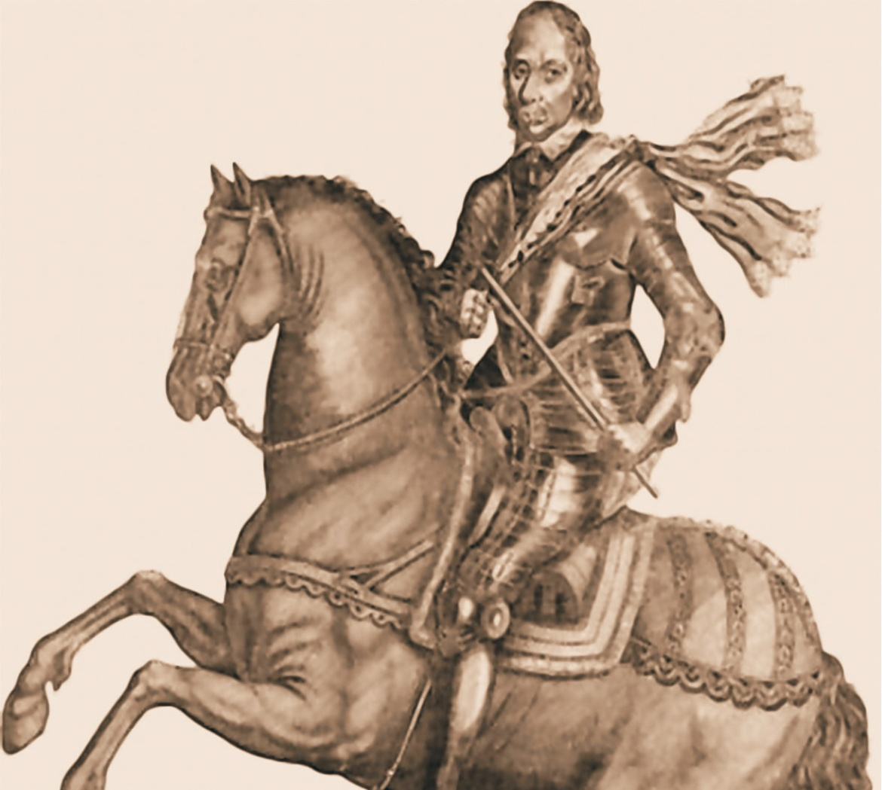

Rule Book
Version 6.0

Table of Contents
1. Introduction ....................................................................... 1 | 5. Combat ............................................................................... 1
2. Components ...................................................................... 1 | 6. Moral and Rally .................................................................. 2
3. Sequence of Play ............................................................... 1 | 7. Optional Rules ................................................................... 2
4. Movement ......................................................................... 1 | 8. Determining Victory ........................................................... 3

1.0 Introduction
The English Civil War is a series of tactical games covering the period from 1642 to 1650. To date, five games have been published in this series. They are: Edgehill: Dawning of the Revolution, Naseby: The End of a Reign, 1st Newbury, Dunbar and Montrose Triumphs.

NOTE: This Rulebook supersedes the earlier versions. Any change in this Rulebook or on the Charts (and not mentioned for a specific battle) apply to all games in the series.

2.0 Components

2.1 Units
Each unit is rated for Combat, Morale and Movement.
Each leader is rated for Command and Movement.
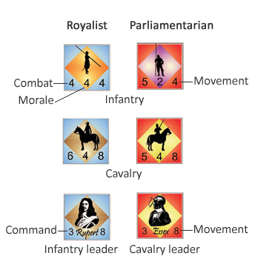

2.2 Charts, Tables and Die
The use of the charts and tables are explained in the rules. The game uses a six-sided die.

2.3 Scale
- 1 turn: 20 to 30 minutes
- 1 hex: 100 to 200 yards
- 1 strength point: 75 to 100 men

3.0 Sequence of play

3.1 Activation Phase
3.1.1 At the start of each turn all the leader activation chits are put in a cup or other opaque container. Both players then alternate drawing from the cup. The drawn leader may be activated (Only once per turn - if an already activated leader chit is drawn, it is put aside and another draw is made).

3.1.2 The phase is ended when all the chits less one are drawn from the cup; so it is possible that one leader would not be activated in a turn.

3.1.3 Once activated the units belonging to that leader may perform the following two actions:
- Movement [4.0]
- Combat [5.0]

NOTE: A player may choose not to activate a leader when his chit is drawn. In the case of a leader with multiple activation chits, this leader may be activated when another chit is drawn, but it's a risky business, as he may not be activated if his is the last chit to remain in the cup.

3.2 Rally Phase
Both players check at the same time for their disordered and routed units. Each unit rolls separately to see if it recovers or not as per Morale and Rally [6.0}

3.3 Victory Check
Both players check to see if their armies are routed or not as per Determining Victory [8.0].

4.0 Movement
Units and leaders move one at a time, expending a single movement point for every hex entered as modified by the Terrain Effects Chart (TEC). There are no Zones of Control (ZOC). In the standard game there are no Command Radius or Facing rules (Note: Command Radius and Facing may be added with the Optional Rules, see below).

5.0 Combat

5.1 Basic Combat Rules
5.1.1 Combat takes place after the completion of movement for all units belonging to the active leader.

5.1.2 Combat is resolved between adjacent units and is not mandatory. A unit deciding to attack must do so against all adjacent enemy units except those that are disordered or routed.

5.1.3 Both players sum the total points of the units involved and refer to the Combat Results Table (CRT) for the ratio found, applying the following modifiers:

- Terrain modifiers as per the TEC.

- "2" leaders add 1 to the die roll for the attacker.

- "3" leaders add 2 to the die roll for the attacker and subtract 1 if defending.

- Morale differential (based on the best morale for each side of the units involved in the combat) is added or subtracted from the roll, depending on whether the attacker or the defender has the better morale.

5.2 Combat Results
Disorder: A Disordered unit may only defend, with the same combat value but one less morale than the printed one, and may move only 1 hex per turn until recovered. A second Disordered result Routs the unit.

Rout: A Routed unit immediately retreat three hexes toward its map hedge. If attacked, it is automatically eliminated.

Eliminated: The eliminated unit is removed from the map.

NOTE: Combat results are cumulative: so a disordered unit that suffers a rout result is eliminated instead.

5.3 Charge
5.3.1: A cavalry unit may charge other cavalry units if it starts its movement no more than 4 hexes but at least 2 hexes away from the target. Such units double their combat factors and add 1 to their morale rating. At the end of the charge they are disordered.

NOTE: If they suffer an adverse combat result, they have to add this automatic disorder to the result rolled.

5.3.2 Cavalry may not charge out of or into woods.

5.3.3 Cavalry is automatically disordered if it charges downhill. This is applied before combat commences although the charge is still completed. An uphill charge is not allowed (only a normal attack).

5.4 Leaders in combat
5.4.1 Each time a leader is involved in combat roll two dice: if the result is "2" or "12" the leader is killed and is eliminated from play.

5.4.2 If a leader is killed, leave only a single chit for him in the draw.

5.4.3 When that counter is next drawn, only one unit of the dead leader’s command may be activated. When doing so place a replacement leader counter on that unit (Use a blank counter).

5.4.4 On second and following turns, when the dead leader’s chit is picked for activation then ALL units in that command are activated. You may still choose not to activate but since this is the only chit, it will be wasted.

NOTE: This simulates the formation taking time to adjust to a new leader taking command.

5.4.5 The Command Value of a replacement leader is zero.

5.4.6 A leader otherwise is never eliminated. Exception: If a leader is alone in a hex he must make the elimination check each time an enemy unit moves into his hex. If he survives, put him with any of the units in his command.

6.0 Morale and Rally
6.1 In the rally phase, Disordered units automatically recover if not adjacent to an enemy unit.

6.2 If adjacent to an enemy unit, the owner rolls a die, subtracting one if the unit is stacked with/adjacent to its leader or a friendly unit with good morale. If the result is equal/less than the morale value of the unit, the unit recovers.

6.3 A Routed unit may recover only if at least 3 hexes away from the nearer enemy unit. The owner rolls a die, subtracting the command value of any one leader stacked with/adjacent. If the result is equal/less than the morale value of the unit, the unit becomes Disordered.

6.4 If the roll fails, the unit is moved two more hexes towards its map edge. If the unit routs off the map it is eliminated.

6.5 If the routed unit is forced to pass through a friendly unit, the latter becomes disordered or if already disordered routes.

NOTE: A leader stacked with a unit routing off the map is not eliminated but simply placed on another unit of his command (owning player’s choice).

7.0 Optional Rules
These rules add a little more realism to the system, with significant variations both to gameplay and to the time necessary to complete a game. They are recommended for competitive play and after a couple of tries with the basic system they should always be used.

7.1 Command Radius
7.1.1 To move its full movement allowance, each unit must start its turn no more than 4 hexes away from its leader (Including the hex the unit is in, but excluding the one there the leader is).

7.1.2 A unit out of Command Radius has its movement allowance halved (rounding down) and cannot attack. It defends normally.

NOTE: The rules for Command Radius still apply to replacement leaders.

7.2 Facing
7.2.1 Each unit must be put on the map facing a hex corner, so that it has a front (2 hexsides), 2 flank hexes and 2 rear hexes.

7.2.2 Each unit may only move and attack through its frontal hexsides.

7.2.3 During the movement phase, each unit may change orientation at the cost of 1 movement point.

7.2.4 If attacking, a unit must attack all enemy units that are in its two front hexes.

7.2.5 If a unit is attacked through a flank hexside, the attacker shifts 1 column to the right on the CRT.

7.2.6 If a unit is attacked through a rear hexside, the attacker shifts 2 columns to the right on the CRT.

NOTE: If multiple attackers assault a unit through more than one such hexsides, use the better differential for the attacker (without adding them).

7.3 Artillery
7.3.1 These are fixed counters. They may not move but in a turn that they do not fire may change facing to any orientation the owner chooses.

7.3.2 To fire, an artillery unit must have a clear Line of Sight (LOS) to the target. This LOS is blocked by any other unit (friendly or enemy), wood hexes, slope hexes (other than the first hex uphill) or hedge hexsides falling between the artillery unit and its target.

7.3.3 All artillery has a fire range of 4 hexes. The only effect they may have on a unit is Disorder. They have no effect on an already disordered unit.

7.3.4 Artillery units may be activated only once per turn by any leader with at least one infantry unit in his command.

7.3.5 To fire, the player rolls 4 dice if the target is adjacent, 3 dice if the target is 2 hexes away, 2 dice if the target is 3 hexes away and 1 die if the target is 4 hexes away.

7.3.6 An infantry target is Disordered if the attacking player rolls a “6”.
7.3.7 A cavalry unit is Disordered if the attacking player rolls a “5” or more.

7.3.8 UNMANNED ARTILLERY
a) An artillery unit firing against an adjacent cavalry unit has to be stacked with an infantry unit. If not, it is instead unmanned (put a blank counter over it to note this).

b) An unmanned artillery unit may regain its operative status in a following turn, if a friendly leader is stacked or adjacent to it and the nearest enemy unit is at least 3 hexes away.

c) Only 1 infantry unit may stack with an artillery unit. If the infantry is forced to retreat because of a combat result, the artillery becomes unmanned (see above).

d) An enemy cavalry unit moving through or ending its movement on an artillery unit eliminates the artillery from play.

e) An enemy infantry unit moving through an artillery unit also eliminates the artillery from play. If the infantry unit ends its movement on the enemy unit, the artillery is captured. The following turn, that player may replace the enemy artillery unit with one of his own.

8.0 Determining Victory
8.1 Players earn Victory Points (VPs) for eliminating or routing enemy units and leaders as follows:
- Each eliminated or routed leader counts as 2 VPs x command value.

NOTE: There are no VPs earned for eliminating replacement leaders.

- Each eliminated or routed combat unit is worth a total equal to its combat value.

- Certain scenarios may give additional VPs.

8.2 During the Victory Check phase total the number of VPs lost by each side. When one side exceeds its rout level the other side wins.

8.3 If both sides exceed the rout level on the same turn the game is a draw. If no side has routed by the end of the last game turn the game is a draw.

