Terrain Effects Chart (4.0)
 |  | MP Cost to Enter |  | Combat Effects
Hex Terrain |  | Infantry | Cavalry | Infantry | Cavalry
Clear | 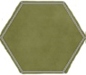 | 1 | 1 | No effect | No effect
Light Woods | 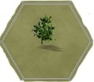 | +1 | +2 | No effect | No effect
Woods | 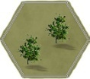 | +2 | +4 | -2 to die roll  (defending) | 1 column shift to left  (attacking)
Town | 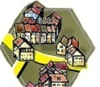 | +2 | +4 | -2 to die roll  (defending) | 1 column shift to left  (attacking)
Marsh | 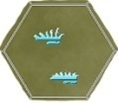 | +3 | Prohibited | Strength halved (Attacking from and defending in) | Prohibited
Sea | 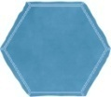 | Prohibited |  | Prohibited
Ford | 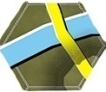 | +2 | +1 | Prohibited
Road | 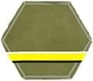 | No effect |  | No effect

Hexside Terrain
Hedge | 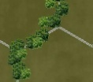 | No effect | +1 | -1 to die roll  (defending through) | -1 to die roll  (attacking through)
Hillside | 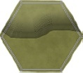 | No effect | +1  (up and downhill) | No effect | 1 column shift to left  (attacking uphill)
River (Alford only) | 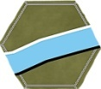 | Impassable by all units if not at a ford |  | Prohibited
Stream (Auldearn and Dunbar only) | 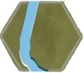 | It takes all the movement points of a unit to cross |  | Prohibited
NOTE: Modifiers are cumulative.

Close Combat Table (5.0)

Die | 1-3 | 1-2 | 1-1 | 1, 5-1 | 2-1 | 3-1 | 4-1 | 5-1 | Results explanation
0 | Ae | Ar | Ad | Ad | Dx | Ne | Ne | Dx | Ae/De: Attacker or defender eliminated
1 | Ar | Ad | Ad | Dx | Ne | Ne | Dx | Dd | Ar/Dr: Attacker or defender routed
2 | Ar | Dx | Dx | Ne | Ne | Dx | Dd | Dd | Ad/Dd: Attacker or defender disordered
3 | Ad | Ne | Ne | Ne | Dx | Dd | Dd | Dr | Dx: Disordered exchange: the defender
4 | Ne | Ne | Ne | Dx | Dd | Dd | Dr | Dr | and one of the attackers (owner's
5 | Ne | Ne | Dx | Dd | Dd | Dr | Dr | De | choice) is disordered
6 | Ne | Dx | Dd | Dd | Dr | Dr | De | De | Ne: no effect
7 | Dx | Dd | Dd | Dr | Dr | De | De | De
8 | Dd | Dd | Dr | Dr | De | De | De | De

GAME TURN | 1 | 2 | 3 | 4 | 5 | 6 | 7 | 8

