20.1 Examples of Play (added per designer 7-20-03)
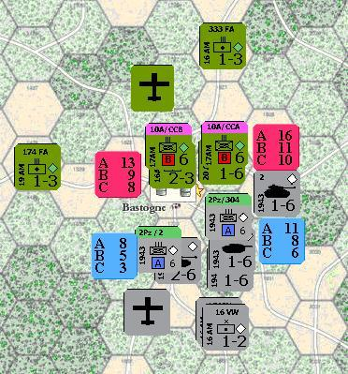
Example 1: Multi-hex combat
In this example, the German 2nd Pz division is attacking the key VP town of Bastogne. Using the two Mech regiments of the division to get a divisional integrity bonus along with some additional tanks and artillery, The German is trying to wrest control of the town from the US 10th Arm. division with it's anti-tank, and artillery. Along with a tank battalion, a second regiment of the 10th Arm. is adjacent, so a defensive shift for divisional integrity is awarded. An additional shift left for the town is helping the US to hold this important road center. Last of all, each player has committed an air point to help support the attack. In order to make a solid attack on this position, the German player will concentrate his effort on the town itself. A diversionary attack in the form of a single tank battalion will attack the tank and one regiment while the rest attack the units in the town.
The combat chits have all been pulled and the main attack is:
Blue A-6 =8 +2 (Attackers strength) and Blue A-6 =11+1+1
The total from both hexes = 23
Vs.
Red B-6 =9+2 (defenders strength) =11
Attackers combat shifts:
Divisional Integrity= 1
Artillery = 2
Combined Arms= 0 -defender has Combined arms defense.
Air Point=1- 1D6 die roll of 3 succeeds.
Defenders combat shifts:
Divisional Integrity= 1
Town shift=1
Artillery=1
Air points=0 -failed on a 1D6 die roll of 5
To sum up, the final totaled points are 23-11 or 2-1 odds.
Canceled Shifts: Each player has one.
Divisional Integrity= 1
Artillery= 1
Remaining Shifts: After canceling.
Attacker: 1 Artillery and 1 Air point
Defender: 1Town shift
2-1 for points, 3-1, 4-1 counting the attackers shifts, then back one for the defensive Town shift to 3-1
Defenders terrain= Rough
Final odds: 3-1 column on the Rough Terrain line.
Roll two dice. The die roll is a 9
Final result is D1-(1). The defender must lose one step-loss and retreat one hex, or lose two step-losses and remain in place.
In this case of a major Victory Point town, the Allied player will opt to lose two steps and remain in Bastogne.
The diversionary attack is now rolled for. The German 1-6 tank is attacking the US regiment of the 10th Arm and the 1-6 tank unit which defends as one defensive total that is supported by one artillery, divisional integrity, and defensive combined arms.
1-6=1 (Attackers strength) =1
B-6=11+1 (Defenders strength) =12
Attackers Combat Shifts: 0
Defenders Combat Shifts:
Divisional Integrity=1
Artillery=1
Defensive Combined Arms=1
1-12 odds 1-13, 1-14, 1-15 after the defensive shifts
Final odds: 1-15 or minimum odds (the far left column)
Roll two dice. The die roll is a 4. Final result is A1-(1)-The tank loses his one step and is removed from the board. The Allied player could advance, but chooses not to.
-----------------------------------------------------------------------------------------------------------
Example 2: Movement
Here are several US units entering in the game on the 17AM game turn as reinforcements from entry road ‘A’.
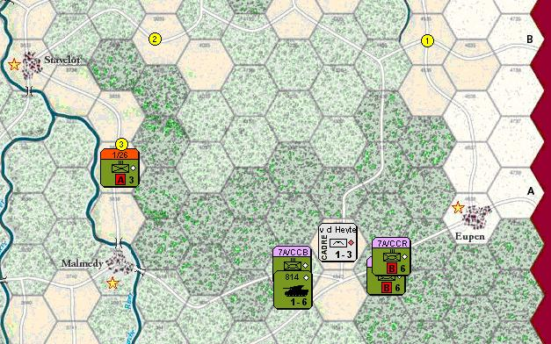
The US movement phase is under way and there are units entering the game map in both tactical and strategic modes. The A-3 unit of the 1st Infantry division/ 26th regiment has just completed a strategic move as the numbered markers show. Since US Non-Mech units have their movement increased X6, the tactical movement allowance of 3 becomes a strategic allowance of 18 if the move is kept to the road. Care must be taken not to come too close to the German paratrooper VDH at any time. As long as units come no closer than 3 hexes to enemy units, they can use the faster strategic mode costs from the Terrain Effects Chart. (See map) The markers show that for every 6 road hexes, one full movement point is spent from the movement allowance. Coming from off-map on road ‘A’, 1/26 has moved its full movement allowance of 18 road moves. Note that the marked road is still far enough away from the VDH enemy unit to still allow the beneficial strategic movement costs.
The 7 Arm Division, plus tank battalion 814 have moved in tactical mode from off board, spending one movement point per road hex entered, and may move adjacent to the VDH unit. These units stayed on the road and were able to get into attack positions. Note that the cadre VDH has no ZOC and one regiment of the 7th Arm moved right past this unit and into position.

------------------------------------------------------------------------------------------------------------

Example 3: Bridge Demolition and Disruption (updated 1/31/04)

In this example, a German armored recon unit has finished movement near to some bridges that the Allied player has planned for demolition. Depending on the distance from the German units and the bridges, the Allied player, in his friendly engineer phase, may, as there are friendly supplied units within 5 hexes of the bridges, attempt the demolition according to the demolition table on the CRT card (see 13.1, 13.2) Each Allied unit can make no more than two demolition attempts.
At the bridge starting on the left, a 1-4 will have to be rolled on one die to demolish the bridge.
Next, a 1-3 must be rolled, as the German units are two hexes away. Since the recon is adjacent, the third bridge will only be blown on a die roll of 1. On the right, a 1-2 must be rolled to demolish this bridge.
Note that the bridge counter at Ettlebruck, representing a bridge previously built by German engineer units, is protected from demolition by combat units on either side of the river and no supply line can be traced to the bridge itself.

If the Allied player attempts to demolish the bridge next to the German commando unit, The German player may attempt to disrupt this roll with his own die roll of 1 or 2. If successful, no attempt at blowing this bridge may be made until the next Allied engineer phase. (See 16.4)
Note that even if 3p/afk Recon were a regiment exerting a ZOC across the river, a demolition attempt by the Allied player would still be possible. Note that Fuel Depots may be similarly destroyed up to five hexes away from German units on a die roll of 1-4.

Example 4: Supply
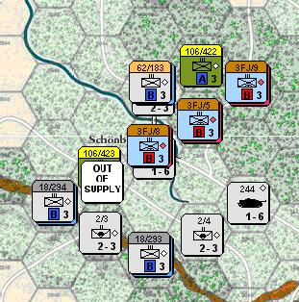
The US 106/423 Infantry regiment is marked as out of supply because it cannot trace a supply line free of enemy controlled hexes (ZOC), back to a friendly controlled road that also leads off map to a friendly supply source. The two German regiments 18/294 and 3FJ /8, that are adjacent, exert a locking zone of control, even in the empty hexes around the regiment. If not for the presence of the other supplied regiment, 106/422, this unit would have been marked as Isolated, increasing further still, the penalties on its ability to function normally.

2D6 percentage odds Chit Average Strengths
2-----------2.77%
3-----------5.55% Front Front
4-----------8.33% Blue Red
5-----------11.11% A-9.01 A-11.46
6-----------13.88% B-6.13 B-8.07
7-----------16.66% C-4.22 C-7.06
8-----------13.88%
9-----------11.11% Back Back
10----------8.33% A-4.28 A-6.36
11----------5.55% B-2.77 B-4.53
12----------2.77% C-1.71 C-3.56

