GPW: Impulse Sequence of Play
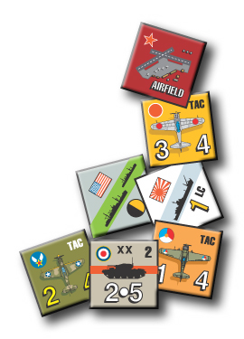
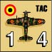
*Upon drawing the appropriate chit, the impulse must be conducted in order noted below.
** Allied units (except Chinese) may be moved in any friendly impulses
listed below.

Naval Impulse:
1. Move units for the purpose of conducting Naval Strikes. Resolve as per 11.6.
2. Move Naval Units and Transport friendly ground units (must be in port w/
naval unit).
3. May conduct one (1) amphibious assault.

Headquarters Offensive:
1. Move air and ground units that begin within 4 hexes of the HQ. Units may move beyond the 4 hex range but must start within 4 hexes.
2. Conduct Offensive Air Support and/or Counter Air w/ Air units that start within four hexes of the HQ.
3. May conduct one (1) airborne assault with a PARA unit that starts at a airbase or city within 4 hexes of the HQ.
4. Active player indicates which hexes he will attack. Target hexes need not be within 4 hexes of HQ, but the attacking units must start within 4 hexes of the HQ. Resolve battles. May conduct exploitation.

Attrition:
1. Place an Attrition marker on a friendly controlled hex. Move any ground units that begin impulse with 3 hexes of this marker.
2. May attack ONE (1) enemy occupied hex. Air units from ONE (1) airbase within 3 hexes of marker may provide Off Air Support. Resolve battle. No Exploitation allowed.

Air Effort:
1. Active player may move and/or conduct Counter-Air, Naval Strikes or Strategic bombing.

General Offensive:
1. May move any and all ground units.
2. Active player may move and/or conduct Offensive Air Support, Counter-Air, Naval Strikes or Strategic bombing.
3. Move Naval Units and Transport friendly ground units (must be in port w/ naval unit).
4. Conduct any number of Amphibious assaults. May combine assault with other ground combat against same hex.
5. Conduct any number of Airborne assaults.
6. Active player indicates all enemy-occupied hexes to be attacked and flies all TAC/SAC units on Off Air Support to said hexes. Resolve battles one at a time. May conduct exploitation.

