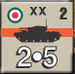
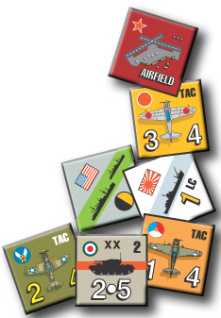

Production and Misc. BRP Cost Chart

Unit Type | BRP Cost | Time to Build
Inf, Cav, Gar | 1 + 1 BRP per Factor | 1 Turn
Arm, Para, Mar | 1 + 2 BRPs per Factor | 1 Turn
TAC, SAC | 3 BRPs per Factor | 1 Turn
SURF, CV, LSAC | 4 BRPs per Factor | SURF, CV = 4 Turns  LSAC = 1 Turn
LC | 3 BRPs per Factor | 1 Turn
SUB | 2 BRPs per Factor | 1 Turn
HQ | 5 BRPs | 1 Turn
Fleet Train | 15 BRPs | 2 Turns
Rebuild Reduced Unit | BRP cost per Factor X Factors Restored
Beachhead, Airbase | 5 BRPs | 1 Turn
General Offensive Chit (once per Year) | 15 BRPs
Offensive, Naval, Air Chit | 5 BRPs
Attrition Chit | 2 BRPs
Sea Control/Raiding Box Deployment | 5 BRPs
Declaration of War  (Minors don’t pay) | 15 BRPs vs. Major  5 BRPs vs. Minor

