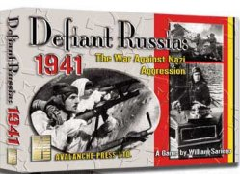

AIR POWER TRACK
Turn Axis Soviet
1 6 0
2 8 0
3 8 0
4 7 1
5 6 2
6 4 2
7 0 4

Note: A maximum of 3 air points may be used to bolster attack. 1 die for each air point. Not allowed during exploitation combat.

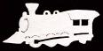
RAIL MOVEMENT
Axis: maximum 3 units (2 during snow)
Soviet: maximum 6 units (no limitation due to snow)
Both: railed units may not otherwise move except during exploitation phase, and must attack if ending turn adjacent to enemy.
Partisans
During Soviet organization phase from turn 4, Soviets rolls 1 die.
1-5 No effect
6 One non-Finnish infantry must be reduced

WEATHER EFFECTS
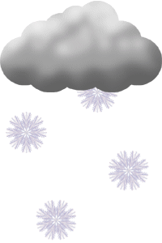
Clear: No effects on movement or combat

Light Mud: No Soviet Exploitation movement phase. Axis units may only move Armor stacked with leader Guderian.

Mud: all movement allowances halved (all fractions round up) and neither side may move during exploitation phase. Armor units may not expend extra movement to move through zones of control.

Snow:
Axis: rail capacity reduced to 2 maximum. Axis supply lines (except Finnish) reduced to 2 hexes. Combat factors (exception: Finnish units and German and Romanian mountain units)halved (round any fraction up) when attacking. Exploitation movement is limited to 1 (for those that may move)

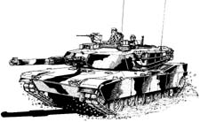
Soviet: attacks on FIRST snow turn hit on 5 or 6.

Computing Combat Factors
1. Compute terrain factors
2. Compute weather factors
3. Compute leader factors
4. Combine results

Exploitation
Axis: German armor have 3 movements points in clear weather. Infantry (including mountain & Italian) have 1 movement point. In snow, Axis units allowed to move ALL have 1 movement point. THE FOLLOWING AXIS UNITS MAY NEVER USE EXPLOITATION MOVEMENT OR COMBAT: Romanian, Hungarian, Finnish, or Spanish. German armor stacked with Guderian are only units allowed to move during exploitation during light mud.

Soviet: No Soviet infantry exploitation movement. In clear and snow Soviet armor have 2 movement points, cavalry and shock units have 1 movement point. No Soviet exploitation in mud.

BOTH: A unit permitted to move during exploitation movement may always move ONE hex,regardless of terrain.

ALL WEATHER AND TERRAIN EFFECTS ARE CUMULATIVE

No Exploitation on Turn 1

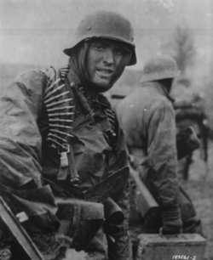
REPLACEMENTS
Axis From turn 3 Axis receives 2 replacement points, 1 armor per turn may receive replacements.

Soviet From turn 2 Soviets receive 6 replacements. -1 for Leningrad, Moscow, Kiev, or Stalingrad if controlled by Axis. Reduced by 1 if rail connection to above cities cannot trace line free of enemy to Soviet map edge. July–September up to two armor units may receive replacement points, October–December only 1 armor unit may receive replacement points.

Both Units must be in supply to receive replacements-- may be in an enemy ZOC. Leningrad is ALWAYS considered to be in supply.

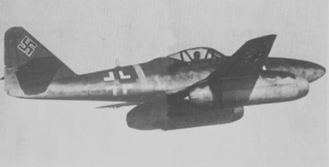
Axis Air Attack
During AXIS combat phase, Axis Air points may be used against a fleet if an Axis unit is within 4 hexes. On a result of 5-6 the fleet is reduced or eliminated. This attack may not take place during exploitation combat phase.

Soviet Airborne
Available only during SNOW turns. Unit begins turn in a city hex. It may move to any hex within 4 hexes. Soviet player immediately rolls 1 die.

1 Unit is destroyed
2-3 Unit is reduced
4-6 No effect

Terrain Combat Effects
Type Effect

Clear None

Mountain +1 each defending unit

Forest + 1 total defender

Swamp + 1 total defender Armor halved

Minor city -1 attacking armor

Major City + 1 total defender
-1 attacking armor

River -1 each attacker across
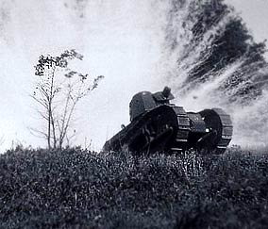
Fortress -1 each attacker
defenders hit on 5-6

Movement Costs
Terrain Effect

Clear None

Mountain inf. & cav 2, armor 3,mtn. 1

Forest armor 2, others 1

Swamp armor 3, others 2

Minor city as other terrain

Major City as other terrain

River armor +1 crossing

Fortress as other terrain


VICTORY
Cities Moscow is worth 2 points. Bryansk, Kharkox, Kiev, Leningrad, Minsk, Rostov, and Sevastopol are worth 1.
Kills killing the most enemy units =1 victory point, Soviet fleets, shock armies, Airborne, and Zhukov count as 2 units. Guderian and German armor units count as 2 units, other German units count as 2. All other Axis units count as 1 unit.
Stalin: alive +1 Soviet, dead + 1 for Axis.
Auto Victory Soviets hold Warsaw & Helsinki. Axis hold Leningrad, Moscow, & Stalingrad at any point.

