1 June ‘41  - No Axis SR in SU  - SU may not retreat adjacent  - SU may not entrench  - No Orders roll | 2 Summer ‘41  - No Axis SR in SU  - SU may not entrench | 3 Fall ‘41  - No Axis SR in SU  - SU may entrench only in Urban spaces/level 1 only | 4 Winter ‘42  - No Axis SR in SU  - SU may entrench only in Urban spaces/level 1 only  - Winter ’42 effects  - No invade A-I  - VP E/SU/I=5
5 Spring ‘42  - No OPS cards first two rounds (Spring Thaw)  - SU may entrench only in Urban spaces/level 1 only | 6 Summer ‘42  - SU may entrench only in Urban spaces/level 1 only | 7 Fall ‘42  - SU may entrench only in Urban spaces/level 1 only | 8 Winter ‘43  - VP E/SU/I=6  - SU may now build trench 2  - No invasions beaches A-I  - 2 RP cards per turn limit to Axis begins
9 Spring ‘43  - No OPS cards first two rounds (Spring Thaw) | 10 Summer ‘43 | 11 Fall ‘43 | 12 Winter ‘44  - No invasions beaches A-I  - 1 RP card per turn limit to Axis begins  - VP E/SU/I=2
13 Spring ‘44  - No OPS cards first two rounds (Spring Thaw) | 14 Summer ‘44 | 15 Fall ‘44 | 16 Winter ‘45  - No invasions beaches A-I  - Axis hand minimum is now 2  - VP E/SU/I=1
17 Spring ‘45  - No OPS cards first two rounds (Spring Thaw)  - Axis hand minimum 2 | 18 Summer ‘45  - Axis hand minimum 2 |  | Barbarossa to Berlin and the graphic at top of chart are registered property and copyright of GMT Games ©2002
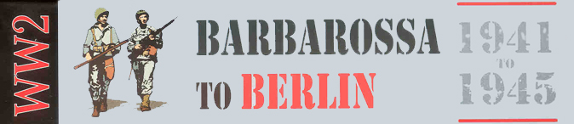
Expanded Game Turn Record Track

