Dropshot Endgames Table Errata

There were a number of tables omitted or incomplete, and some – the Morale Tables - that are completely wrong.

STRATEGIC NUCLEAR STRIKE TABLE (Dropshot II – Turbulent 60’s
Die | Bombing factors
roll | 1 | 2 | 3 | 4+ | Bomber DRMs
0 | Loss | Loss+Abort | Loss | Loss | -1 per INT in hex
1 | Loss | Loss+Abort | Abort | D1 | -1 if air defenses strong (scenario specific)
2 | Abort | Abort | D1 | D2 | +1 attacks by low level penetration aircraft
3 | Abort | D1 | D1 | D2
4 | D1 | D1 | D2 | D3 | Missile DRM’s
5 | D1 | D2 | D2 | D3 | +1 DRM: Missiles with a ‘+’
6 | D2 | D2 | D3 | D3
7 | D2 | D3 | D3 | D3
* Loss = lose 1 attacking bomber
* Abort = all surviving bombers return to friendly bases with no effect on target hex
* D# = nuclear damage to hex. (# = NDM’s)
* You can only make one attack per phase against a hex (Exception French/Chinese: 8.11 or rule 8.13)
* NDM Damage is cumulative from previous strikes.
* Missiles attacking Hard Targets require at least a D2 to kill. A D3 kills two hard targets in hex.
* Bombers kill 1 Hard Target with any result. A ‘D3’ kills two hard targets in hex.
* At least a ‘D2’ cumulative result is required to destroy any fleets in a targeted port.
* A D2 destroys one submarine in port or coast hex, and a D3 destroys two submarines.
* TAC air, INT air and fleets at sea are never affected by Strategic Nuclear Strike.

UNCONVENTIONAL WARFARE TABLE for DROPSHOT II – 60’S; Amend as follows:
SABOTAGE SUCCEEDS ON A DIE ROLL OF ‘1’. SABOTAGE ONLY USED ON T-1

CONVENTIONAL BOMBING – Dropshot II, Turbulent 60’s
Die Roll Result
1 Lose 1 bomber unit
2-3 No Effect
4-6 Oil or Ind neutralized 1 turn

SOVIET PLAYER EXCLUSIVE TABLES

Dropshot II – Turbulent 60’s:
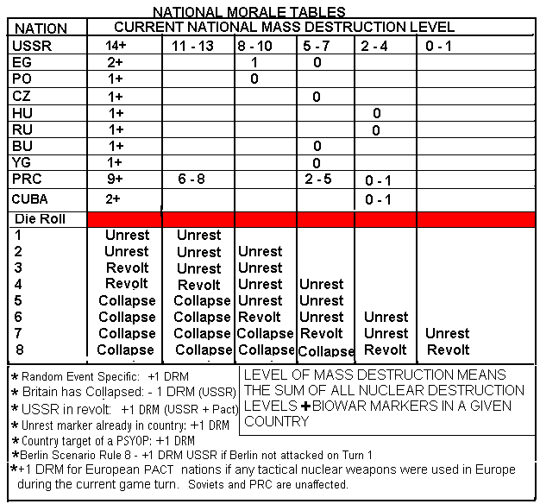
Dropshot III – End Games (70’s – 90’s)
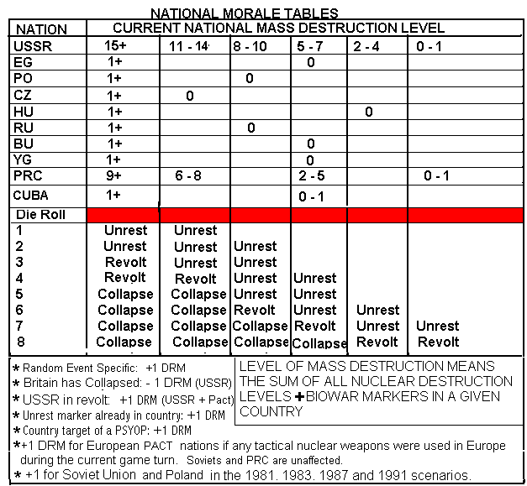

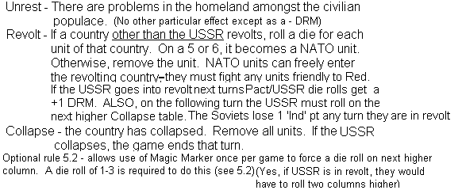

UNIT CONSTRUCTION: Dropshot Endgames – (Note – no Motor Armies can be built in Dropshot III).
Mountain Army – Ind Cost Build Time
2 3

OIL POINT TRACK – The Soviets can store up to 8 Oil Points in Dropshot Endgames (70’s – 90’s)

ALLIED PLAYER EXCLUSIVE TABLES
Allied Morale Table, Dropshot II – Turbulent ‘60’s
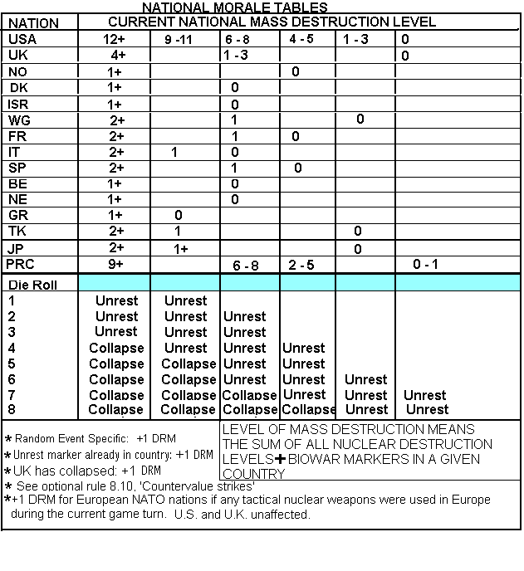
Allied Morale Table, Dropshot III –End Games
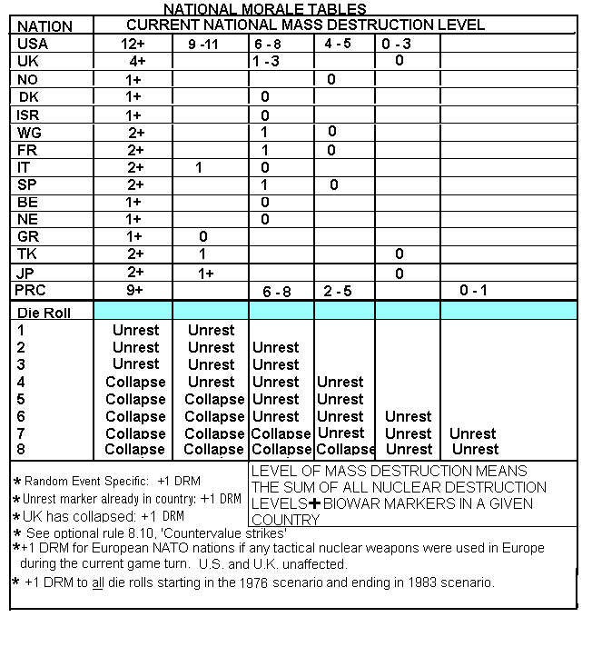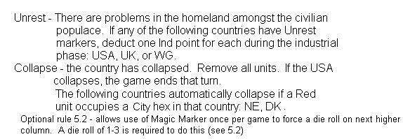
ALLIED UNIT CONSTRUCTION IN DROPSHOT III – ENDGAMES, CHANGES AS FOLLOWS:
Ind Cost Build Time
Fleets 7 11
Bombers 3 8
AirLand Corps 4 5

Oil Point Costs – Both Games
If an oil point is not paid for production, the cost is -3 Ind points.

