Official Desert Fox Errata, Clarifications, and Addenda of 21 December 1995
With derived clarifications and example corrections Version 1.3
By Don Johnson 01/22/2014, new items with V1.4 are prefixed with *.

Here is the official (published) errata/addenda as complied from Moves #58, 60, and S&T Special Issue #1 for the Desert Fox game from S&T issue #87.

(Note that the following up to Hank’s name is obsolete information.)
Questions on the existing Desert Fox (SPI) or information on Desert Fox
Deluxe (Decision Games) can be sent to me by e-mail. I'd very much like to hear your comments, ideas, and suggestions on how the existing game system works for you and what you'd like to see reworked or added.

Some unofficial errata, clarifications, rules, options, and experimental variants can be found in the Desert Fox <extra stuff> file/page. Enjoy! Questions on the existing Desert Fox (SPI) or information on Desert Fox Deluxe (Decision Games) can be sent to me by e-mail. I'd very much like to hear your comments, ideas, and suggestions on how the existing game system works for you and what you'd like to see reworked or added.

Some unofficial errata, clarifications, rules, options, and experimental variants can be found in the Desert Fox <extra stuff> file/page. Enjoy!

Hank Meyer
hcmeyer@uci.edu
Executive Producer
Chameleon Interactive Media
Laguna Beach, California 92651 USA

**************************************************************************

Published Addenda to Desert Fox:

Doctrine for Desert Fox by Matisse Enzer in Moves #58 (published by SPI), an operational analysis of play which includes three additional rules for the game: Operation Herkules (the invasion of Malta), Detachments (four new unit-counters), and Desert Patrols (five new unit-counters). These didn't make it into the game due to space and counter limitations.

Optional Rules for Desert Fox by Richard Berg (the game's designer) in Moves #60 (published by SPI), including Commonwealth Variable Withdrawal and Return (three new tables), Axis Use of Tobruk as a Port, and rules for Rommel (one new unit-counter). These didn't make it into the game due to space and counter limitations.

Fox Killed by Steven Copley in S&T Special Issue #1 (published by TSR), a prequel to the Desert Fox game covering the Italian Offensive and
O'Connor's Counter-offensive from Sep 40 thru Mar 41 (23 new unit counters, two new tables). There are also compiled errata for Desert Fox, which is relatively complete and comprehensive.
------------------------------------------------------------------------------

Published Errata and Clarifications to Desert Fox:

Counters:
The Italian Artclre Armd Arty unit arrives on Game-Turn 13 (not 18 as shown on the unit counter). The Axis Reinforcement Schedule (5.18) also incorrectly reads turn 18.

Commonwealth 6/2 NZ enters on Game Turn 3 (as per the Commonwealth Reinforcement Schedule) instead of on turn 2 (as printed on the counter).

The Movement Allowance for Italian 101/Tri Heavy Wpns remains 14 when the unit is depleted (the counter reads 28).

Commonwealth 1FF should be 2 stacking Points on both its depleted and non-depleted sides. Commonwealth 2FF should be 1 stacking point on both sides.

Charts and Tables:
Benghazi should be the equivalent of a Level 1 Fortification, not a Level
2. Shift Benghazi down to the next row on the Combat Results Table.

On the Summary of Supply Sources and Capacities, "U/U/-" was mistakenly printed in the bottom right-hand position of the summary. It should read "U/-" instead.

[5.17] Commonwealth Reinforcement/Withdrawal Schedule.
(Addition): "150/50 Mtrzd" returns on Game-Turn 12 after being withdrawn on turn 6.
(Correction): "Delete "5/3 Ind(3)" from Game-Turn 4 withdrawals; "5/4 Ind(2)" is removed instead.
(Clarification): "1/2, 4/7 and 7/7 Armd" arrive in the Refit Box on Game-Turn 3, as correctly indicated on the Reinforcement Schedule. It should be noted that these units cannot actually be rebuilt until Game-Turn 4 because of Armor Rating restrictions (see Case 13.3).

[7.57] Axis Convoy Arrival Table.
(Correction): The note to this table is wrong with regard to the Game-Turns on which rolls on the table are modified. The information in Case 7.55 is correct.

[8.29] Terrain Effects Chart and Key
(Important Addition): Roads NEGATE hexside movement costs. Tracks HALVE the cost of hexside terrain.

Rules:
[5.1] (Addition): Reinforcements may not be placed on the map overstacked.
Reinforcements must be delayed if they cannot be placed without violating stacking restrictions.

[7.9] (Clarification): This case does apply to dumps captured in the current turn by the phasing player. These dumps trace a line of communications as any other dumps owned by the phasing player.

[8.37] (Clarification): A player must roll for disruption immediately following any reaction movement to overruns (see 8.46).

[8.43] (Clarification): This rule applies only at the end of each reacting unit's movement. A reacting unit may move by enemy units which are not already in friendly ZOCs (within the restrictions of ZOCs and movement in general) provided that it does not end its movement adjacent to such units.

[8.51 and 8.61] (Clarification): When these rules indicate "one unit or
Stacking Point (whichever is greater)", they mean that the criteria for permitting movement is either "no more than one unit" or "no more than one Stacking Point." For example, a unit with a Stacking Point Value of "1", another unit with a value of "0", and three MSUs (also with Stacking Point Values of "0") could all be moved by rail or by sea, since all five units together comprise only one Stacking Point. On the other hand, a unit with a
Stacking Point Value of "2" and an MSU could NOT use naval and rail transport as they together comprise 2 stacking points AND 2 units. The unit with a value of "2" could be transported by itself, however.

[11.4] (Correction): An infantry-type unit worth more than 1 Stacking Point could satisfy the combined arms needs of more than one armored unit stacked with it. Each infantry-type Stacking Point will satisfy the combined arms requirement for 1 Stacking Point of friendly armor.

[11.62:3] (Addition): Motorized units may also retreat through sand sea and marsh hexes along a track.

[11.9] (Correction): The Commonwealth unit "22(2)" is portrayed in the example at an Armor Rating of 2. The example should have used the "22(3)" counter, indicating an Armor Rating of 3. In the example its combat strength would then be 4 after halving for combined arms effects.

[13.2] (Addition): A line is missing. The fourth sentence of this Case should read "Non-motorized units which are eliminated and cannot trace a line of communication go into the Destroyed Units Box." (Combat supply status is irrelevant.) The next sentence should then begin, "If a motorized unit which is out of Combat Supply or cannot trace a line of communication is eliminated, the owning player..."

Additional derived clarifications by Don Johnson as of 01/22/2014
Inserted words are underlined. New text in 2014 is prefixed with an *.

[2.22] Heavy Infantry was omitted as a unit type; this is a rectangle with an infantry X symbol with a heavy bar on the left, as with the Heavy Airborne Infantry type. This is important for Commonwealth Withdrawals rule 5.22 where the same type of unit can be substituted; specifically, the 18 Aus Heavy Infantry withdrawal on turn 6 has no possible substitute unit. *(Rationale: This can be seen in section 2.5 in the second paragraph on unit type abbreviations which contains “Hvy Inf (Heavy Infantry)” as one of the abbreviations; it can also be seen on 13.26 on the Refit Chart on the map where the heavy infantry type symbol is the third entry in the third row.)

*[2.23] The only game use of a unit's organizational size is to determine the Refit point costs for a non-motorized infantry regiment, brigade, or division.

*[6.31] Per the Operation Herkules optional rules, the CW player may ship 2 air points to Malta each Air Allocation phase only when there is a CW unit in general supply west of Lxx23; otherwise the CW may ship only 1 air point.

[7.12] states “Friendly units negate enemy ZOCs for purposes of tracing supply lines.” but [10.27] states ‘No form of supply may be trace to or through a supply unit in an enemy ZOC unless that supply unit is stacked with one or more friendly combat units.” [7.12] should be corrected to state “Friendly combat units negate enemy ZOCs for purposes of tracing supply lines.”

*[7.15] Add sentence “Any number of 0 Stacking Point units may participate in the same defense at no stacking point cost in supply.”

[8.29] Note that motorized units cannot attack across escarpment hexsides and no unit can attack across a sea hexside (one is near Bardia). Any unit can attack into a sand sea or marsh hex, but a motorized unit will not be able to advance after combat into such a hex unless using a road or track, per [8.14]. (Rationale via reduction to absurdity: If an enemy unit with a ZOC is in a marsh hex and a friendly motorized unit is adjacent to that enemy unit and in that enemy ZOC, then assume (for a minute) that a motorized unit cannot attack into a marsh hex, then the enemy unit both must be attacked yet cannot be attacked. To avoid this contradiction, it must be the case that motorized units can attack into a hex that they cannot move into.)

*[9.25] Instead of placing eliminated units due to overstacking in the Refit Box, use the procedure in rule 13.2 for deciding where they go, since that procedure says it is to be used whenever a unit a eliminated. Rule 13.2 traces a line of communication from the eliminated unit to El Aghelia or Alexandria.

[10.1] Item 4 says “The ZOC of a pure armor or reconnaissance unit does not extend into mountain hexes.” But all the reconnaissance units in the game have 0 stacking points, so they do not have a ZOC at all, per [10.11], so the sentence should be corrected to say “The ZOC of a pure armor unit does not extend into mountain hexes.”

[11.34] If only part of a defending force is being attacked across hexside terrain, any units attacking any defending units across hexside terrain are subject to the modifications of 11.37. Example:
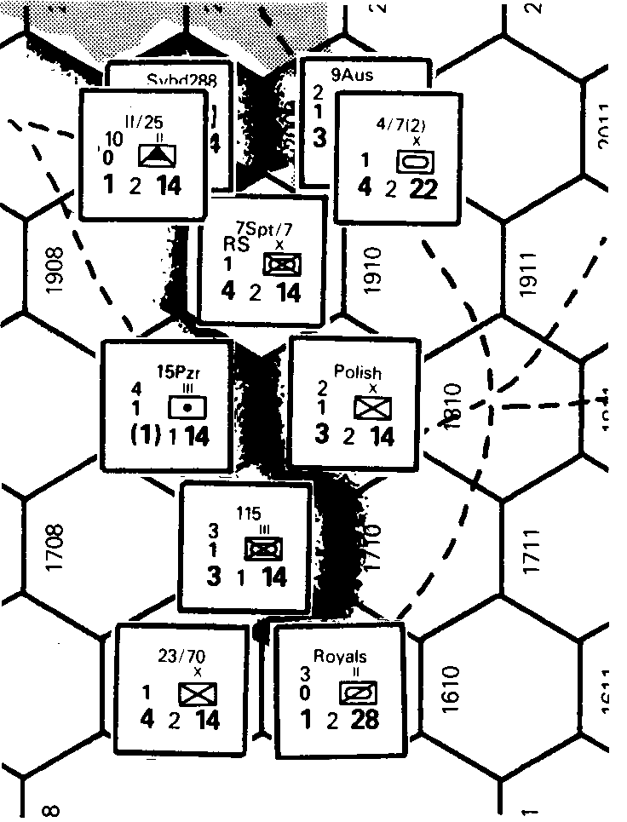

It is the beginning of a Commonwealth Combat Phase. The Commonwealth player allocates his attacks as follows: 23/70, Royals Reece, and Polish attack 115 Mech; 9 Aus Hvy Wpns and 4/7(2) Armd attack II/25 Flak and Svbd 288 Hvy Wpns. 7Spt/7 Mech cannot attack as it is a motorized unit separated from all enemy units by escarpment hexsides (rule 11.36). 15 Pzr Arty need not be attacked because it does not have a ZOC.
Polish’s Combat Strength is divided by 3 because of the ridge, and becomes a 1. Royals Recce's Combat Strength also becomes a 1, (1/3, rounded up). 23/70's Combat Strength remains at 4 as it is not attacking across a ridge. 4/7 Armd’s Combat Strength is 2 (4/3, rounded up). 9 Aus Hvy Wpns’ Combat Strength is 1 (3/3). II/25 Flak's ability to reduce the Combat Strength of armor units is unaffected by the ridge and thus 4/7 Armd’s Combat Strength is reduced to 0. Similarly, 9 Aus Hvy Wpns’ artillery capability is unimpaired by the ridge.

If it were an Axis Combat Phase and 115 Mech were attacking Polish 23/70 and Royals Reece; 115 Mech's Combat Strength would be reduced to 1 because of the ridge, even though 23/70 is not being attacked across a ridge.

[11.9] COMBAT EXAMPLE
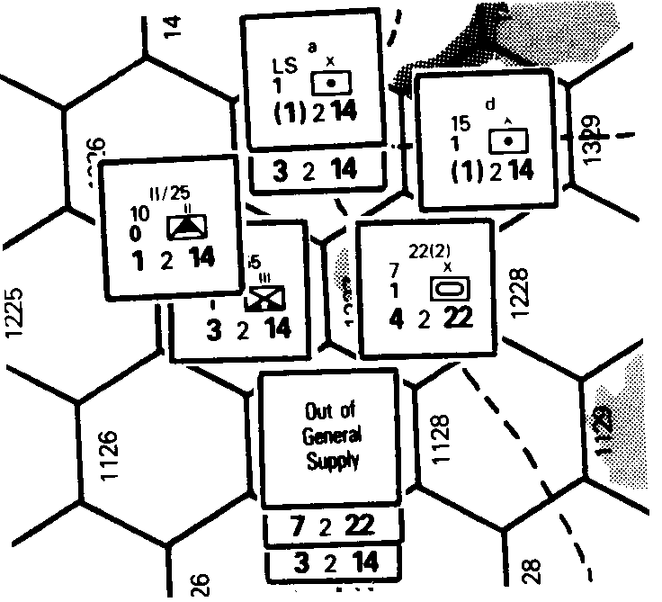

It is a Commonwealth Combat Phase. "a" Arty, 25/10 Ind Hvy Wpns, 22 Armd, 44 Hvy Wpns, and 1/2 Armd are all attacking II/15 and 155 Mtrzd. "d" Arty is not adjacent to enemy units and thus may not participate in the attack.

25/10 Ind Hvy Wpns' Combat Strength is 3. "a" Arty adds nothing to the combat strength of the attacking force. 22 Armd's Combat Strength is halved to 2 because it is not stacked with any infantry-type units (see 11.4 Combined Arms Effects). 1/2 Armd attacks at full Combat Strength because it is stacked with 44 Hvy Wpns. The fact that 1/2 Armd is out of General Supply has no effect on its combat ability. 44 Hvy Wpns functions at full Combat Strength (3). The attacking force's total Combat Strength is thus 3+0+2+7+3=15. More than 4 of those Combat Strength points are contributed by armor units, however, so Axis 11/5 can use its anti-tank ability (12.0) and deduct 4 from the total Combat Strength of the attacking force to yield a total Combat Strength of 11. The defending force has a Combat Strength of 4 (3 + 1). The combat ratio is 11/4= 2.75, which is rounded (in favor of the defender) to 2:1. The defending force is in clear terrain, so the attack is executed on column 4.

The Commonwealth player rolls a 5 on the die. Adding 5 to 4 (the column number derived above), the Commonwealth player determines that the adjusted column number is 9. The Commonwealth player may add up to 2 to this column as a result of artillery shifts ("a" Arty and 44 Hvy Wpns each contribute an artillery shift), for the purposes of determining effects on the Axis forces only. Artillery shifts never affect the column on which results against friendly forces are determined. Thus Axis losses will be found on column 11, while Commonwealth losses are found on column 9. Cross-indexing column 11 with each defending unit's Morale Rating, it is determined that each defending unit suffers a 4d result and must retreat 4 hexes and be disrupted. In addition, the attacking player may apply one depletion result (because of the p) against either of the defending units. Cross-indexing column 9 with the Effect on Attacking Units row, it is found that the attacking force suffers a p result, and thus the defending player can apply one depletion result against any one of the attacking units.

*[11.4] Combined Arms Effects: The rules text mentions unit but the example mentions stacking points. Use the example as normative, so whenever the word “unit” is mentioned earlier in the rule, it should say “stacking point”.

*[11.67] A chain of MSUs may be used to trace supply for purposes of removing disrupted markers; such usage is unlimited and no MSUs are expended for this reason, see the Summary of Supply Sources and Capacities chart as corrected by errata.

*[13.2] RESTRICTIONS ON REFIT
Whenever a unit is eliminated for any reason, it is placed in the Refit Box, unless it was out of Combat Supply, or could not trace a path of any length through traversable hexes to Alexandria (Commonwealth) or L0701 (Axis) unimpeded by enemy units and ZOCs. The term “traversable hexes” means hexes that are traversable by the unit tracing the LOC; for a supply dump, trace as a motorized MSU. Friendly combat units negate enemy ZOCs for this purpose. A path of this type is termed a "line of communication." Non-motorized units that are eliminated and cannot trace a line of communication go into the Destroyed Units Box. (Combat supply status is irrelevant.) If a motorized unit which is out of Combat Supply or cannot trace a line of communication is eliminated, the owning player rolls a die; on a 1, 2, or 3; the unit is placed in the Refit Box; otherwise it is placed in the Destroyed Units Box and may never again appear on the map. Motorized units with Morale Ratings of 1 *when depleted which are out of Combat Supply or cannot trace a line of communication are placed in the Refit Box on rolls of 1, 2, 3, or 4 and only go into the Destroyed Units Box on a 5 or 6.
*(Rationale: Both sides have units that have a morale of 1 when undepleted but a morale of 2 when depleted, so it is ambiguous what to do in this case; for consistency, only when the depleted side of a unit has a morale of 1 is the
enhanced chance used to not be destroyed.)

[13.23] says “Commonwealth units may not be rebuilt from scratch if Alexandria is enemy-occupied or in an enemy ZOC.” But a ZOC does not extend into a city hex (rule 10.12 item 2), so it should be corrected to say “Commonwealth units may not be rebuilt from scratch if Alexandria is enemy-occupied.”

*[14.21] Also, a unit in a fort cannot be overrun, see rule 8.36.

*[15.15] Another way for the Axis to win Race for Tobruk is by taking Alexandria according to rule 15.25 from the Campaign game.

*[15.26] Benghazi is in L2306, not E2306.

Differences between the 1981 SPI S&T edition and the 2006 Six Angles edition are the following:

Counters: The SPI edition needs some corrections, per the errata; the 6A edition includes those corrections, as well as the extra counters needed for the Fox Killed 1940 Italian campaign variant, the Rommel variant, the detachments variant and the desert patrol variant published in Moves and S&T. The 6A edition also includes a new counter for a Tiger company variant, which has a new type of heavy panzer.

Maps: The main difference is the SPI map uses a 5 symbol code to identify a hex, first indicating the map by L for Libya and E for Egypt and then a 4 digit hex number, while the 6A map just has a 4 digit hex number. The 4 digits are the same on the Libya map, to covert SPI EXXYY is 6A XXYY+0032 (for example, Bardia is SPI E2104 which converts to 6A 2136). The 6A map has a typo, misspelling the Via Balbia coastal road as Via Barbia. The 6A map places Sidi Azeiz in the hex where Fort Capuzzo is on the SPI map and places Fort Capuzzo in the hex directly east of that on the road between Bardia and Sollum. On the 6A map, the CW Reinforcement/Withdrawals Schedule has been corrected per the errata and both the CW and Axis schedules are easier to use than the SPI version as there are spaces for the actual units to be placed and an indication when a returning unit comes back.

Scenarios: The SPI edition has 2 scenarios: (1) the 5 monthly turn Race for Tobruk and (2) the 22 turn Campaign. The Fox Killed variant adds 2 scenarios: (3) the 7 turn Italian Campaign and (4) the 28 turn Extended Campaign. The 6A edition has 6 scenarios, the 4 above and also 2 new 3 turn practice scenarios on the new Map C with enlarged hexes showing the area around Tobruk needed to play Scenario 5 Operation Crusader (turns 41/11 to 42/1) and Scenario 6 Gazala Battle (turns 42/5 to 42/7).

Don Johnson's suggested rules changes:
- Map: Gazala should be in hex L2324, not L2323. Tmimi is about 50 km from Gazala as the crow flies and hexes are 16 km across, so 3 hexes away from Tmimi on the coast is where Gazala should be, not 2 hexes away. See wiki map of North Africa on Battle on Gazala.
- [6.22] At most 2 air points may be assigned to one combat.
Rationale: Air points do not cost stacking points and perhaps more importantly, they do not count cost 2 stacking points for supply like units with artillery do. Once 4 air points are accumulated, this strangles the ability of the opposing player to have combat, as the column can be shifted 4 columns with no tradeoffs due to costs of stacking or supply consumption.
- [8.1] Suggest the main 2 types of units be called mech and leg, as one syllable terms, this is much shorter that motorized and non-motorized and avoids possible confusion when naming a unit type.
- [11.16] When an attack is made at a ratio lower than the lowest listed, then this “illegal” attack must be resolved before any legal attacks and the defender may choose any combat result found anywhere on the CRT for the result that applies to the attacking units, from no effect to eliminated.
- [12.17] A CW full strength Heavy Weapons with Artillery brigade may cost either 1 or 2 stacking points of supply. If the CW spends 2 stacking points of supply, then it has artillery capability and if the CW only spends one then it does not have artillery capability. (Rationale: when depleted, it has no artillery capability, the supply stacking point cost is 1.)
- [14.14] To contruct a fort, a unit must be in general supply.

